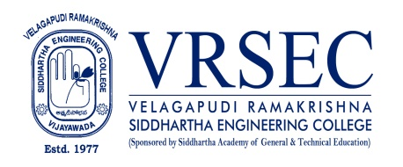
BULLA SUJITHA
 | Designation  E-Mail ID  Contact at | : Assistant Professor  : bullasujitha@gmail.com  : 357,Department of Electronics and communication  Engineering, Velagapudi Ramakrishna Siddhartha  Engineering College, Kanuru, Vijayawada, Andhra  Pradesh 520007.
Education
M.Tech (Electronics and communication Engineering)
2019, Jawaharlal Nehru Technological University, Kakinada
B.Tech (Electronics and communication Engineering)
2016, Jawaharlal Nehru Technological University, Kakinada
Experience

Period | Designation | Institution / Organization
2022-Till date | Assistant Professor | Velagapudi Ramakrishna Siddhartha Engineering College
2020-2022 | Assistant Professor | Vasireddy Venkatadri Institute of Engineering College

Courses Taught
- Digital logic design
- Linear integrated circutes and applications
Research Profile
Publications
The recent publications and research contributions can be viewed from the following URLs
Google Scholar | https://scholar.google.com/citations?user=U5z42j0AAAAJ&hl=en

Professional Development Activities - Participations
Faculty Development and Training Programmes  (at least 5 Days) | 6
International / National Level Seminars | 0/ 0
International / National Level Conferences | 02 / 0
Workshops | 1
Instructor Led / Self-Paced Courses | 3
Webinars | 2

(Bulla Sujitha)
***

