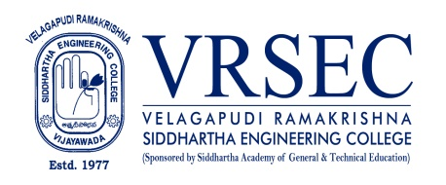
J. Sravanthi
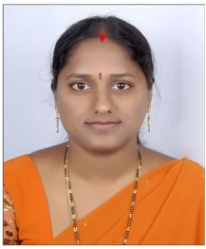 | Designation  E-Mail ID  Contact at | :Assistant Professor  : janakisravanthi@gmail.com  : Department of Electronics and Communication Engineering,  Velagapudi Ramakrishna Siddhartha Engineering College,  Kanuru, Vijayawada, Andhra Pradesh 520007.
Education
M.Tech (Embedded Systems)
2012, Jawaharlal Nehru Technological University, Hyderabad
B.Tech (Electronics and Communication Engineering)
2006, Jawaharlal Nehru Technological University, Hyderabad
Experience

Period | Designation | Institution / Organization
2022 | Assistant Professor | Velagapudi Ramakrishna Siddhartha Engineering College.
2021-2022 | Assistant Professor | Narasaraopeta engineering College Autonoum, Narasaraopet
2019-2020 | Assistant Professor | Chalapathi Institute Technology, Guntur
2012-2017 | Assistant Professor | Rishi M.S.Institute of Engineering &Technology, Hyderabad
2006-2010 | Assistant Professor | Narasaraopeta engineering College, Narasaraopet
Research Interests : Embedded Systems
Broad Area of Research : Nil

Honors and Awards: Nil

Courses Taught

- Micro Processors and Microcontrollers
- Embedded systems
- Internet of Things
- Switching Theory and Logic Design
- Electronic Devices and Circuits
Research Profile
Publications:Nil
Recognized Research Supervisor: Nil
Funded Research Projects: Nil

Consultancy / Industry Projects: Nil

Patents: Nil
Invited Talks: Nil
Professional Service / Reviewer : Nil
Professional Development Activities - Participations
Faculty Development and Training Programmes  (at least 5 Days) | 3
International / National Level Seminars | 02
International / National Level Conferences | 02
Workshops | 4
Instructor Led / Self-Paced Courses | 0
Webinars | 3

Professional Bodies Membership Details: Nil

(J.Sravanthi)
***

