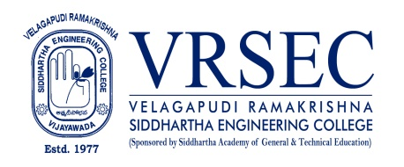
M.Naga Raju
 | Designation  E-Mail ID  Contact at | : Assistant Professor  : nagarajumeena@gmail.com  : Room No. EC-339, Staff Room-3,  Department of Electronics and Communications Engineering,  Velagapudi Ramakrishna Siddhartha Engineering College,  Kanuru, Vijayawada, Andhra Pradesh 520007.
Education
M.Tech. (VLSI&ES)
2013Jawaharlal Nehru Tchnological University, Kakinada
B.Tech. (Electronics and Communication Engineering)
2010, Jawaharlal Nehru Technological University, Hyderabad
Experience

Period | Designation | Institution / Organization
2022-Till | Assistant Professor | Velagapudi Ramakrishna Siddhartha Engineering College, Vijayawada
2014-2022 | Assistant Professor | KKR & KSR Institute of technology and Science, Vinjanampadu, Guntur.

Research Interests
Broad Area of Research :
- Micro/Nanoelectronics Devices
- Wireless Communication

Courses Taught
- Digital Logic Design
- Basic electronic devices
- Electronic Devices & Circuits
- Pulse And Digital Circuits
- Electronic Circuit Analysis
- Analog Communications
- Switching Theory and Logic Design
- Computer Organization
- Integrated Circuits Applications

Professional Development Activities - Participations
Faculty Development and Training Programmes  (at least 5 Days) | 07
International / National Level Seminars | NIL
International / National Level Conferences | 01 / 01
Workshops | 03
Instructor Led / Self-Paced Courses | 00
Webinars | 05

Professional Bodies Membership Details
LM114073 | Member of ISTE with reference number( LM114073)
173246 | Member in IAENG with member ship number(173246)
AM10100057406 | Member in the IRED with member ship number( AM10100057406)

(M.Naga Raju)
***

