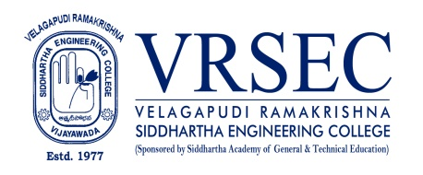
Sunkara Teena Mrudula
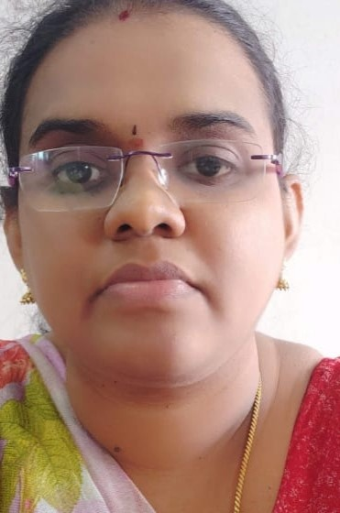 | Designation  E-Mail ID  Contact at | : Assistant Professor  : sunkara mrudula @gmail.com  : EC355,Department of Electronics and communication Engineering,  Velagapudi Ramakrishna Siddhartha Engineering College,  Kanuru, Vijayawada, Andhra Pradesh 520007.
Education
M.Tech (VLSI DESIGN)
2013,Intellectual engineering college, Jawaharlal Nehru Technological University, Anantapur
B.Tech (Computer Science and Engineering)
2008,Sri KrishnaDevarayaEngineering College, Jawaharlal Nehru Technological University, Hyderabad
Experience

Period | Designation | Institution / Organization
2022-tilldate | Assistant Professor | Velagapudi Ramakrishna Siddhartha Engineering College
2019-2022 | Assistant Professor | DVR & Dr HS MIC College of Technology
2018-2019 | Assistant Professor | Sri Krishnadevaraya Engineering college
2017-2018 | Assistant Professor | Intell Engineering college
2014-2017 | Assistant Professor | Sri Krishnadevaraya Engineering college
2008-2011 | Assistant Professor | Sri Krishnadevaraya Engineering college
Research Interests
Broad Area of Research :
VLSI,Signal Processing
Courses Taught
- Probabaility theory and stochastic processes
- Control systems
- VLSI
- Digital Electronics
- Digital IC Applications
- Switching theory and logic design
Research Profile
Publications
The recent publications and research contributions can be viewed from the following URLs
Scopus | https://www.scopus.com/authid/detail.uri?authorId=57211212735
Professional Development Activities - Participations
Faculty Development and Training Programmes  (at least 5 Days) | 7
International / National Level Seminars | 0/1
International / National Level Conferences | 0/2
Workshops | 3
Instructor Led / Self-Paced Courses | 3
Webinars | 2

Professional Bodies Membership Details
AM17 1842-0 | INSTITUTE OF ENGINEERS

SUNKARA TEENA MRUDULA

***

