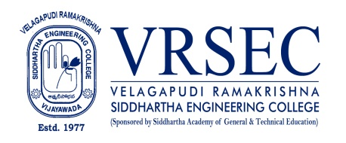
Dr.B LAKSHMI SIRISHA
 | Designation  E-Mail ID  Contact at | : Associate Professor  : suravarapuls@yahoo.co.in  : 70093,Department of Electronics and Communicaion  Engineering, Velagapudi Ramakrishna Siddhartha  Engineering College, Kanuru, Vijayawada, Andhra Pradesh  520007.
Education
Ph. D (Electronics and Communicaion Engineering)
2018, Jawaharlal Nehru Technological University, Kakinada
M.Tech (Communication and Signal Pocessing)
2007, Bapala Engineering college, Bapala.
AMIETE (Tele Communicaion Engineering)
2005, Delhi University, New Delhi.
Experience

Period | Designation | Institution / Organization
2018 - Till now | Associate Professor | Velagapudi Ramakrishna Siddhartha Engineering College
2007 - 2017 | Assistant Professor | Velagapudi Ramakrishna Siddhartha Engineering College
Research Interests
Broad Area of Research :
Digital Image Processing, Digital Video Processing
Honors and Awards
Student Feed back appriciation letter
Courses Taught
- UG: Digital electronics , Analog communications, Linear integrated circuits, Digital image processing
- Digital signal Processing ,Signals and systems, Digital communications, image and video processing,
data compression.
- PG: Video Processing, Transformation techniques, Advanced communication systems
- Multimedia communication , Advanced signal processing, Digital image and video processing

Research Profile
Publications
The recent publications and research contributions can be viewed from the following URLs
Scopus author | https://www.scopus.com/authid/detail.uri?authorId=57303119100
Google scholar | https://scholar.google.com/citations?user=0uOD2zoAAAAJ&hl=en
IEEE  xplore | https://ieeexplore.ieee.org/search/searchresult.jsp?queryText=lakshmi%20sirisha&highlight=true&returnType=SEARCH&matchPubs=true&ranges=2015_2022_Year&returnFacets=ALL&searchWithin=b%20lakshmi%20sirisha
UGC Journals | http://www.jetir.org/view?paper=JETIR2005105
 | http://www.jetir.org/view?paper=JETIR2005002
Recognized Research Supervisor
S.No. | Department | University
1 | ECE | JNTUK
2 | ECE | SRM University, Chennai.
Funded Research Projects
Completed | 01 (NRSC Project, Hyd)

Professional Development Activities – Participations

Faculty Development and Training Programmes  (at least 5 Days) | 10
International / National Level Seminars | 02 / 02
International / National Level Conferences | 04 / 03
Workshops | 15
Instructor Led / Self-Paced Courses | 04
Webinars | 02
Professional Bodies Membership Details
M147747 | MIETE

(Your Name)
B.LAKSHMI SIISHA

