Active Learning Method: JAM ( Just A Minute)
Introduction: JUST a MINUTE The activity ‘Just a minute or JAM’ is an spontaneous speech where the speaker is supposed to express the idea (s) on the given topic, within the duration of a minute. It is quite common to see a speaker experiencing nervousness when asked to speak instantly. Effective unprepared speaking is a skill that can be learnt through practice and training.
Elements of JAM
1. Analyze, assimilate ideas
2. Analyze audience needs
3. Use proverbs , jokes and anecdotes to retain the audience’s interest
4. Quote examples from their self experiences.
The important rules to be followed are;
1. No deviation
2. No repetition
3. No hesitation
Do’s
Be ready to speak in an any given situation
Be brief and to the point
Be cautious of time
Follow a sequential order
Don’ts
Jumble ideas
Drag the point
Go on and on
Give too many pauses
Shy away from expressing your ideas

ACTIVE LEARNING
Name of the Faculty: Dr.Shaik Fathimabi | Designation: Senior Assistant Professor | Subject: Big Data
Year/ Semester: III/II | Section: A&B | Topic: Hadoop Ecosystem
Name of the activity: JAM Just A Minute | Date: 10-04-2022 | No. of students attended:40

Objective of the activity:
JAM on Hadoop Ecosystem and its components
Execution Plan:
Time management: Class time: 50 mins
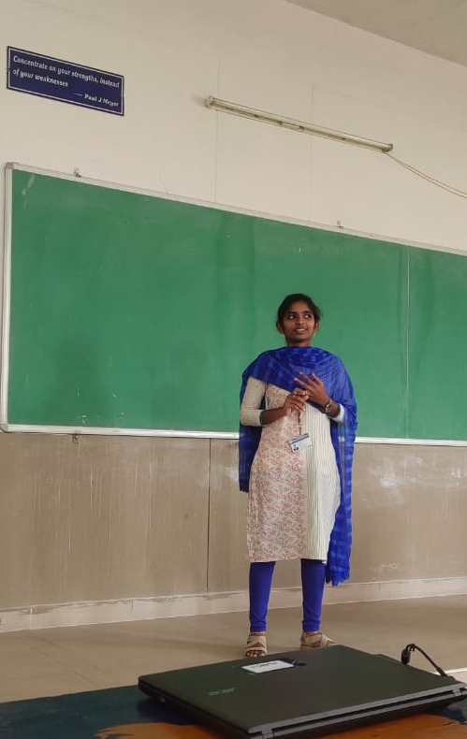
Planning : 5minutes -
- One leader to ask question
- Share to ALL : 1min for All
- Activity : 20 students participated each 2 minutes
- Course coordinator summary : 5mins

Expected Outcomes:
The students can be able to speak on the given topic, it improves the students communication skills and presentation skills, body language
To improve the confidence level

Supporting Evidences of the Activity:

Output:
Third year students actively participated in JAM and presented the given topic.
This activity improves the presentation skills and confidence level of the students.
Students learned about the time management and what we can present in one minutes
This activity removes the fear in students.

