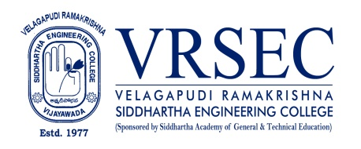
Dr. G. Jamuna Rani
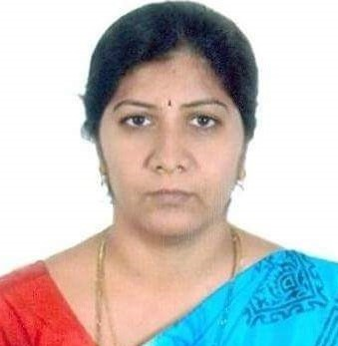 | Designation  E-Mail ID  Contact at | : Assistant Professor  : jamunarani@vrsiddhartha.ac.in  : ME108,Department of Mechanical Engineering,  Velagapudi Ramakrishna Siddhartha Engineering College,  Kanuru, Vijayawada, Andhra Pradesh 520007.
Education
Ph. D (Mechanical Engineering)
2021, Jawaharlal Nehru Technological University, Kakinada
M.Tech (Thermal Engineering)
2005, Jawaharlal Nehru Technological University, Hyderabad
B.Tech (Mechanical Engineering)
2002, Andhra University, Vizag
Experience

Period | Designation | Institution / Organization
2013-till date | Assistant Professor | Velagapudi Ramakrishna Siddhartha Engineering College
2011-2013 | Assistant Professor | KL University
2007-2011 | Assistant Professor | SSN Engineering College
Research Interests
Broad Area of Research :
Alternate Fuels, IC engines, Thermal Engineering

Courses Taught
- Applied Thermodynamics
- Fluid Mechanics and Hydraulic Machines
- Heat Transfer
- Advanced IC engines
- Refrigeration and Airconditioning
- Solar Energy Utilization
- Non Conventional Sources Energy
- Turbomachines
- IC Engines and Gas Turbines
- Engineering Graphics
Research Profile
Publications
The recent publications and research contributions can be viewed from the following URLs
Google Scholar | https://scholar.google.com/citations?user=75GN6xgAAAAJ&hl=en
Scopus | https://www.scopus.com/authid/detail.uri?authorId=57201730728
ORCID | https://orcid.org/0000-0002-0186-6135
Publons | https://publons.com/researcher/3045264/jamuna-rani-ganipineni/
Research Gate | https://www.researchgate.net/profile/Jamunarani_Ganipineni/publications
Linkedln | https://www.linkedin.com/in/jamuna-rani-96b3171b0/
Professional Development Activities - Participations
Faculty Development and Training Programmes  (at least 5 Days) | 11
International / National Level Seminars | 08 / 02
International / National Level Conferences | 5 / 0
Workshops | 10
Instructor Led / Self-Paced Courses | 5
Webinars | 12
Professional Bodies Membership Details
LM 110180 | Indian Society for Technical Education (ISTE)

G. Jamuna Rani
***

