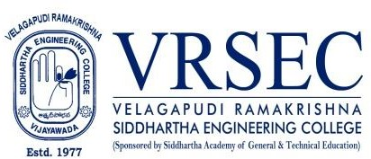

Sandeep Kappa
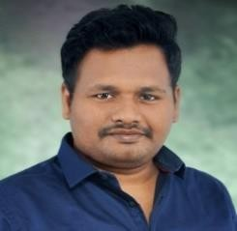
Designation  E-Mail ID Contact at | : Assistant Professor  : ksandeep@vrsiddhartha.ac.in  : ME307,Department of Mechanical Engineering,  Velagapudi Ramakrishna Siddhartha Engineering College, Kanuru, Vijayawada, Andhra Pradesh 520007.

Education

M.Tech (CAD CAM)
2017, Jawaharlal Nehru Technological University, Kakinada

B.Tech (Mechanical Engineering)
2014, Jawaharlal Nehru Technological University, Kakinada

Experience

Period | Designation | Institution / Organization
May 2019-Till Date | Assistant Professor | V. R .Siddhartha Engineering College
Nov 2017-March 2019 | Assistant Professor | Amrita Sai Institute Of Science And Technology
Research Interests

Broad Area of Research :
- CAD/CAM/CIM
- Rapid Prototyping
- Composites
- Finite Element Methods

Courses Taught
- Engineering Mechanics
- Engineering Graphics
- Strength Of Materials

Research Profile

Publications
The recent publications and research contributions can be viewed from the following URLs

SMENEC | http://smenec.org/wp-content/uploads/Mar2018-v13-i1-Sundeep.pdf

Professional Development Activities - Participations

Faculty Development and Training Programmes  (at least 5 Days) | 04
International / National Level Seminars | NIL
International / National Level Conferences | NIL
Workshops | 03
Instructor Led / Self-Paced Courses | NIL
Webinars | 02

(Sandeep K)

***

