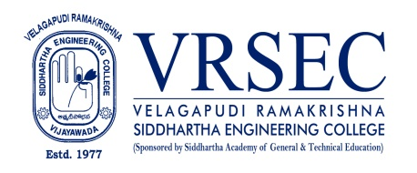
Dr.G.Sridevi
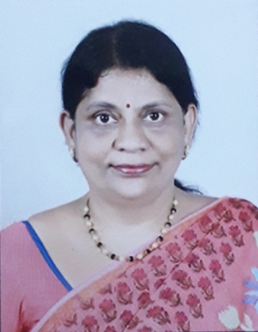 | Designation  E-Mail ID  Contact at | : Associate Professor and HOD  : dr1sridevi@gmail.com,hodphysics@vrsiddhartha.ac.in  : 90006,Department of Physics,  Velagapudi Ramakrishna Siddhartha Engineering College,Kanuru, Vijayawada, Andhra Pradesh 520007.
Education
Ph. D (Physics)
2003, Andhra University, Visakhapatnam
M. Phil (Physics with Electronics specialization )
1995, Andhra University, Visakhapatnam
PGDSM ( Systems Management)
1993, NIIT, Visakhapatnam

M.Sc. (Physics with Electronics specialization)
1992, Andhra University, Visakhapatnam
B.Sc. (Physics specialization)
1989, Maris Stella College, Nagarjuna University,Vijayawada
Experience

Period | Designation | Institution / Organization
2012-2022 | Associate Professor | Velagapudi Ramakrishna Siddhartha Engineering College
2009-2012 | Sr. Assistant Professor | Velagapudi Ramakrishna Siddhartha Engineering College
2001-2009 | Assistant Professor | Velagapudi Ramakrishna Siddhartha Engineering College
1994-1996 | Lecturer | Pydah Degree College, Visakhapatnam
Research Interests
Broad Area of Research :
Solid State Physics, Ultasonics

Honors and Awards
- University 3rd rank in M.Sc. - Andhra University
- University 1st in M.Phil. - Andhra University

Courses Taught
- Engineering Physics-EMF Theory
- Applied Physics
- Physics For Engineers
- Materials Science
- Optics & Thermodynamics,Modern Physics
Research Profile
Publications : Total : 14 (International : 12 National: 02)
The recent publications and research contributions can be viewed from the following URLs
Google Scholar | https://scholar.google.com/citations?user=MHlWmVcAAAAJ&hl=en
Scopus | https://www.scopus.com/freelookup/form/author.uri?zone=TopNavBar&origin=resultslist
ORCID | https://orcid.org/orcid-search/search?searchQuery=G.SRIDEVI
Publons | https://publons.com/researcher/3699367/sridevi-gutta/
Research Gate | https://www.researchgate.net/profile/Gsridevi_Gs
LinkedIn | https://www.linkedin.com/in/gutta-sridevi-90443074/
Recognized Research Supervisor
S.No. | Department | University
01. | Physics | Jawaharlal Nehru Technological University, Kakinada

Funded Research Projects
Completed | 00
On-going | 00
Applied | 00

Consultancy / Industry Projects
Completed | 00
On-going | 00
Applied | 00

Patents
Granted | NIL
Published | 00
Applied | 00
Invited Talks
No. of Invited Talks | 01

Professional Service / Reviewer
- ---.

Professional Development Activities - Participations
Faculty Development and Training Programmes  (at least 5 Days) | 04
International / National Level Seminars | 04 / 14
International / National Level Conferences | 04 / 05
Workshops | 20
Instructor Led / Self-Paced Courses | 01
Webinars | 16

Professional Bodies Membership Details
LM72513 | Indian Society for Technical Education (ISTE)
Life Member | The Indian Thermodynamic Society

(Dr.G.Sridevi)
***

