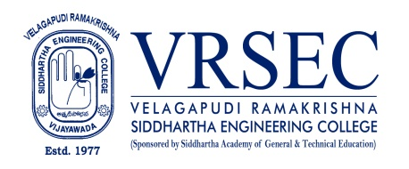
Dr. Kolla Narendra
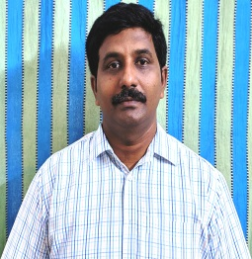 | Designation  E-Mail ID  Contact at | : Associate Professor  : drkollanarendra@gmail.com  : Department of Physics,  Velagapudi Ramakrishna Siddhartha Engineering College,  Kanuru, Vijayawada, Andhra Pradesh 520007.
Education
Ph. D (Physics)
2012, Acharya Nagarjuna University,Guntur
M.Phil (Physics)
2008, Acharya Nagarjuna University,Guntur
PGDCA
1999, University of Hyderabad,Hyderabad
M.Sc (Physics)
1997, SSL Jain College, Vidisha, Affiliated to Barkatulla Vishwavidyalaya,Bhopal
B.Sc (M.P.C)
1995,P.B. Siddhartha College of Arts & Science, Vijayawada
Experience

Period | Designation | Institution / Organization
2018-till date | Associate Professor | Velagapudi Ramakrishna Siddhartha Engineering College
2004-2018 | Assistant Professor | Velagapudi Ramakrishna Siddhartha Engineering College
1999-2004 | Lecturer | Vijetha Junior & Degree College, Hyderabad
1998-1999 | Lecturer | GVR & S College, Guntur
Research Interests
Broad Area of Research :
Thermodynamic and TransportProperties of Liquid Mixtures, Excess Thermodynamic Properties

Honors and Awards
- Received ‘Best NSS Programme Officer’ award from JNTUK, Kakinada on 07-07-2020.
- Received ‘Chukkapalli Pitchaiah Best Teacher Award’ from Siddhartha Academy, Vijayawada on 20-12-2019.
- Received ‘Unsung Hero’s Award’ for best support of blood camp-2019 from Rural and Urban Development Society on 15-12-2019.
- Received ‘Chatrapathi Award-2019’ for the Voluntary Blood donation & Social Activities from Shivaji Youth Foundation, Nellore on 17-02-2019.
- Received ‘Flag Bearer Award’ from Red Cross Society, Vijayawada on 02-10-2015.
Courses Taught
- Engineering Physics
- Physics for Engineers
- Applied Physics
- Material Science
Research Profile
Publications: 120
The recent publications and research contributions can be viewed from the following URLs
Google Scholar | https://scholar.google.co.in/citations?user=6mzfQk0AAAAJ&hl=en&oi=ao
Scopus | https://www.scopus.com/authid/detail.uri?authorId=36523792600
ORCID | http://orcid.org/0000-0002-0347-3845
Publons | https://publons.com/researcher/1387285/kolla-narendra/
Research Gate | https://www.researchgate.net/profile/Narendra_Kolla4
LinkedIn | https://www.linkedin.com/in/dr-kolla-narendra-20809a86/
Recognized Research Supervisor
S.No. | Department | University
Funded Research Projects
Completed | 00
On-going | 00
Applied | 00

Consultancy / Industry Projects
Completed | 00
On-going | 00
Applied | 00

Patents
Granted | NIL
Published | 00
Applied | 01
Invited Talks
No. of Invited Talks | 01

Professional Service / Reviewer
- Reviewer of Journal of Molecular Liquids
- Reviewer of International Journal of ambient Energy
- .
Professional Development Activities - Participations
Faculty Development and Training Programmes  (at least 5 Days) | 10
International / National Level Seminars | 10 / 23
International / National Level Conferences | 08 / 09
Workshops | 20
Instructor Led / Self-Paced Courses | -
Webinars | 18
Professional Bodies Membership Details
LM-265 | The Indian Thermodynamic Society
LM-307 | Ultrasonic Society of India
IASTA-LM-623 | Indian Aerosol Science and Technology Association
917829 | Member in the ‘Asian Council of Science Editors’ Since March 21st 2021.

(Dr. Kolla Narendra)

