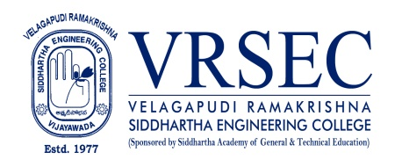
DR. B. RUPA VENKATESWARA RAO
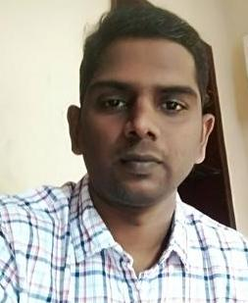 | Designation  E-Mail ID  Contact at | : Assistant Professor  : rupaphysics@gmail.com  : S&H-I 309,Department of Physics,  Velagapudi Ramakrishna Siddhartha Engineering College,  Kanuru, Vijayawada, Andhra Pradesh 520007.
Education
Ph. D (Physics)
2014, Acharya Nagarjuna University, Guntur
M.Sc (Physics)
2005, University of Madras, Chennai
B.Sc (M.P.C)
2002, Acharya Nagarjuna University, Guntur
Experience

Period | Designation | Institution / Organization
2008-2022 | Assistant Professor | Velagapudi Ramakrishna Siddhartha Engineering College
2005-2008 | Assistant Professor | Koneru Lakshmaiah College of Engineering
Research Interests
Broad Area of Research :
Glass Science and Technololg, Material Science

Honors and Awards

Courses Taught
- Engineering Physics
- Applied Physics
- Physics For Engineers
- Circuit Theory/Network Analysis
Research Profile
Publications: 26
The recent publications and research contributions can be viewed from the following URLs
Google Scholar | https://scholar.google.com/citations?user=3xNapvMAAAAJ&hl=en
Scopus | https://www.scopus.com/freelookup/form/author.uri?orcidId=0000-0001-9912-0114
ORCID | https://orcid.org/ 0000-0001-9912-0114
dblp | --------
Publons | https://publons.com/researcher/1332864/rupa-b/
Research Gate | https://www.researchgate.net/profile/Rupa_V_rao
LinkedIn | https://www.linkedin.com/in/dr-rupa-v-rao-b-b704021a9/
Recognized Research Supervisor
S.No. | Department | University
01.
02.
Funded Research Projects
Completed
On-going
Applied

Consultancy / Industry Projects
Completed
On-going
Applied

Patents
Granted
Published
Applied
Invited Talks
No. of Invited Talks

Professional Service / Reviewer
- Reviewer in Macromolecular Symposia, WILEY
- Reviewer in Indian Journal of Pure & Applied Physics, CSIR-NISCAIR
- Reviewer in Material Science Research India
- Reviewer in Boson Journal of Modern Physics
- Reviewer in Oriental Journal of Physical Sciences
- Editorial Member in International Journal of Computational Mathematical Ideas

Professional Development Activities - Participations
Faculty Development and Training Programmes  (at least 5 Days) | 07
International / National Level Seminars | 09 / 10
International / National Level Conferences | 10 / 06
Workshops | 18
Instructor Led / Self-Paced Courses | 02
Webinars | 18

Professional Bodies Membership Details
176249 | International Association of Engineers (IAENG)

(DR. B. RUPA VENKATESWARA RAO)
***

