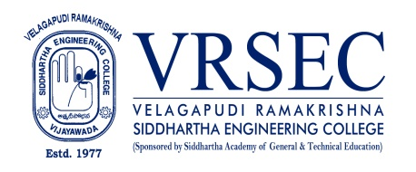
NIRMAL RAJEEV YERRAMALLA
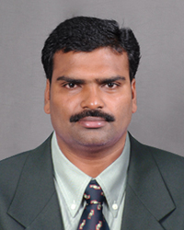 | Designation  E-Mail ID  Contact at | : Assistant professor  : rajeevnirmaly@gmail.com  : S&H I 309,Department of Physics,  Velagapudi Ramakrishna Siddhartha Engineering College,  Kanuru, Vijayawada, Andhra Pradesh 520007.
Education
Ph. D (Submitted )
2012,Acharya Nagarjuna University,Guntur
M.Sc. (Physics)
2006, Loyola College,Chennai,Madras University, Tamilnadu
B.Ed. (Maths, Physics)
2004, Fathima College of Education, Kakatiya University,Warangal
B.Sc. (Maths, Physics, Electronics)
2002, Andhra Loyola College,Vijayawada, Acharya Nagarjuna University,Guntur
Experience

Period | Designation | Institution / Organization
2009-Till date | Assistant Professor | Velagapudi Ramakrishna Siddhartha Engineering College
2007-2009 | Lecturer | Gowtham Degree College, Vijayawada
2006-2007 | Lecturer | Little Flower Junior College, Mylavaram

Research Interests
Broad Area of Research :
Nano Materials, Crystal Growth & Nano Phosphors

Honors and Awards
- . Cleared CSIR -NET in DEC 2012, Qualified for Lectureship
- . Cleared AP SET 2012, Qualified for Lectureship

Courses Taught
- Engineering Physics
- Applied Physics
- Physics for Engineers
- Final Year B.SC. degree course
Research Profile
Publications
The recent publications and research contributions can be viewed from the following URLs
Google Scholar | https://scholar.google.co.in/citations?user=xd8a558AAAAJ&hl=en
Scopus | https://www.scopus.com/authid/detail.uri?authorId=56955806600
ORCID | 0000-0002-5982-8983
dblp
Publons
Research Gate
LinkedIn
Recognized Research Supervisor
S.No. | Department | University
01.
02.
Funded Research Projects
Completed | NIL
On-going | NIL
Applied | NIL

Consultancy / Industry Projects
Completed
On-going | NIL
Applied | NIL

Patents
Granted | NIL
Published | NIL
Applied | NIL
Invited Talks
No. of Invited Talks | NIL

Professional Service / Reviewer
- NIL.
Professional Development Activities - Participations
Faculty Development and Training Programmes  (at least 5 Days) | 01
International / National Level Seminars | 07 / 12
International / National Level Conferences | 05 / 09
Workshops | 19
Instructor Led / Self-Paced Courses | 02
Webinars | 12

Professional Bodies Membership Details
--- | ----
--- | -----

(Mr.Y.Nirmal Rajeev)
***

