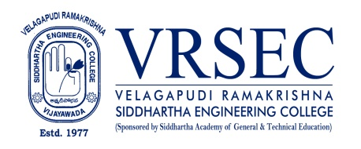
Dr. Naresh Padamati
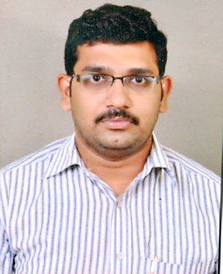 | Designation  E-Mail ID  Contact at | : Assistant Professor  : nareshp6@rediffmail.com, drnaresh@vrsiddhartha.ac.in  : Department of Physics,  Velagapudi Ramakrishna Siddhartha Engineering College,  Kanuru, Vijayawada, Andhra Pradesh 520007.
Education
Ph. D (Condensed Matter Physics)
2015, Acharaya Nagarjuna University, Guntur
M.Phil (Condensed Matter Physics)
2010, Acharaya Nagarjuna University, Guntur
M.Sc (Condensed Matter Physics)
2006, Acharaya Nagarjuna University, Guntur
B.Sc (Maths, Physics, Computers)
2004, Kakatiya University, Warangal
Experience

Period | Designation | Institution / Organization
2012-Till date | Assistant Professor | Velagapudi Ramakrishna Siddhartha Engineering College
2008-2012 | Assistant Professor | Vikas college of Engineering and Technology
2006-2008 | Lecurer | Vikas Degree and P.G. College
Research Interests
Broad Area of Research :
Glass Science and Technlogy, Nano materials, Ultrasonics

Honors and Awards
- Best Paper presentation at National Seminar on “Physics and Chemistry of Non-crystalline Materials”, 1st and 2nd December, 2017, Kakani Venkata Ramana College, Nandigama, Krishna, Andhra Pradesh.
Courses Taught
- Engineering Physics-EMF Theory ( For Graduation)
- Applied Physics ( For Graduation)
- Physics for Engineers ( For Graduation)
- Waves & Ocillations (for Graduation)
- Optics & Thermodynamics (for Graduation)
- Quantum Mechanics (for Post Graduation)
- Soild State Physics (for Post Graduation)
- Statistical Physics (for Post Graduation)
- Classical Mechanics (for Post Graduation)
Research Profile
Publications
The recent publications and research contributions can be viewed from the following URLs
Google Scholar | https://scholar.google.co.in/citations?hl=en&user=PlDE5QkAAAAJ
Scopus | https://www.scopus.com/authid/detail.uri?authorId=54783052900
ORCID | https://orcid.org/0000-0002-8584-5752
Publons | https://publons.com/researcher/3697845/naresh-padamati/
Research Gate | https://www.researchgate.net/profile/Naresh_Padamati
LinkedIn | https://www.linkedin.com/in/naresh-padamati-630a97160/
Recognized Research Supervisor
S.No. | Department | University
-- | --- | ---
Funded Research Projects
Completed | 00
On-going | 00
Applied | 00

Consultancy / Industry Projects
Completed | 00
On-going | 00
Applied | 00

Patents
Granted | NIL
Published | NIL
Applied | NIL
Invited Talks
No. of Invited Talks | NIL

Professional Service / Reviewer
- NIL

Professional Development Activities - Participations
Faculty Development and Training Programmes  (at least 5 Days) | 07
International / National Level Seminars | 05 / 19
International / National Level Conferences | 03 / 00
Workshops | 13
Instructor Led / Self-Paced Courses | 02
Webinars | 8

Professional Bodies Membership Details
LM114100 | Indian society of Physics teachers

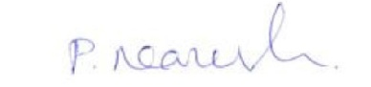

(P. Naresh)
***

