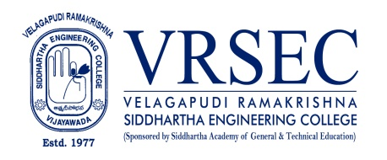
CH.VIJAYA LAKSHMI
PHOTO  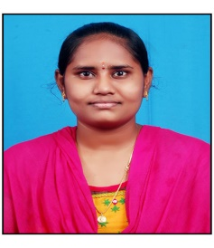 | Designation  E-Mail ID  Contact at | : Assistant professor  : Vijayalakshmichilukuri19504@gmail.com  : S&H I 306,Department of Physics,  Velagapudi Ramakrishna Siddhartha Engineering College,  Kanuru, Vijayawada, Andhra Pradesh 520007.
Education

M.Sc. (Physics)
2021, P.B.SIDDHARTHA COLLEGE OF ARTS AND SCIENCES
B.Sc. (Maths, Physics, Electronics)
2019 , NALANDA DEGREE COLLEGE AND PG CENTRE
Experience

Period | Designation | Institution / Organization
2021-Till date | Assistant Professor | Velagapudi Ramakrishna Siddhartha Engineering College

Research Interests
Broad Area of Research :

Honors and Awards
NIL
Courses Taught
NIL
Research Profile
Publications
The recent publications and research contributions can be viewed from the following URLs
Google Scholar | NIL
Scopus | NIL
ORCID | NIL
dblp | NIL
Publons | NIL
Research Gate | NIL
LinkedIn | NIL
Recognized Research Supervisor
S.No. | Department | University
01. | NIL
02. | NIL
Funded Research Projects
Completed | NIL
On-going | NIL
Applied | NIL

Consultancy / Industry Projects
Completed
On-going | NIL
Applied | NIL

Patents
Granted | NIL
Published | NIL
Applied | NIL
Invited Talks
No. of Invited Talks | NIL

Professional Service / Reviewer
- NIL.
Professional Development Activities - Participations
Faculty Development and Training Programmes  (at least 5 Days) | NIL
International / National Level Seminars | NIL
International / National Level Conferences | NIL
Workshops | NIL
Instructor Led / Self-Paced Courses | NIL
Webinars | 02

Professional Bodies Membership Details
--- | ----
--- | -----

***

