Report on
Problem Solving and Programming in Python Phase – 1&2

Department of S&H , V.R Siddhartha Engineering College Organized Six Half day Hands on workshop on Problem Solving and Programming in Python Phase – I with resource persons from APSSDC.
Schedule for the workshop
Session | Phase | Dates | Participated Students Count
Problem Solving and Programming in Python Phase - I | Phase I | 17-23 December, 2019 | 61
Problem Solving and Programming in Python Phase - II | Pahse II | 30 December 2019 to  08 January 2020 | 61
About the Workshop:
Six Half day Hands on Workshop on Problem Solving and Programming in Python Phase – I &II with APSSDC. Python Developer is designed by Python development training team. Python Basic programming concepts starting from hello world basic knowledge on python programming will be delivered in this Workshop.
Target audience: I/IV B.Tech. Students of Department of S&H, VRSEC
Venue: IT CMSkill Lab.
Resource Persons:

- Sri Boppana Ravisastry,APSSDC
- Sri Mandoori Venkata Gopi,APSSDC
Outcomes:
- After this workshop students will be good at Basic Knowledge in Programming which helps them to get better Job opportunities.
Course Content:
Day | Content
1 | - Inauguration,Registrations,Introduction  - Literate Programming  Jupyter Notebook Environment  - Markdown format for documentation  - Python basics
2 | - String Slicing, functions with examples  - Python Functions  - Conditional Statements  Iteration  - Lists
3 | - Tuples, Sets  - Dictionaries  - Packages and Modules  - Regular Expression
4 | - File Handling  - File Processing  - List,Dictionary Comprehensions  - Iterators  - Generators
5 | - Maps  - Filter  - Lambda  - Numpy  - Pandas
6 | - Pandas  - Data Visualization using Matplot Library  - AWs

Convener
Dr. M. Suneetha, Prof & HOD, IT
Coordinators
Dr G Ramakoteswara rao
B.L.N. Phaneendra Kumar
M.Ashok kumar
V.Radhesyam
Organized by
Department of S&H
V.R Siddhartha Engineering College Vijayawada-7
In Association with APSSDC

Sponsored by
Siddhartha Academy of General& Technical Education
Vijayawada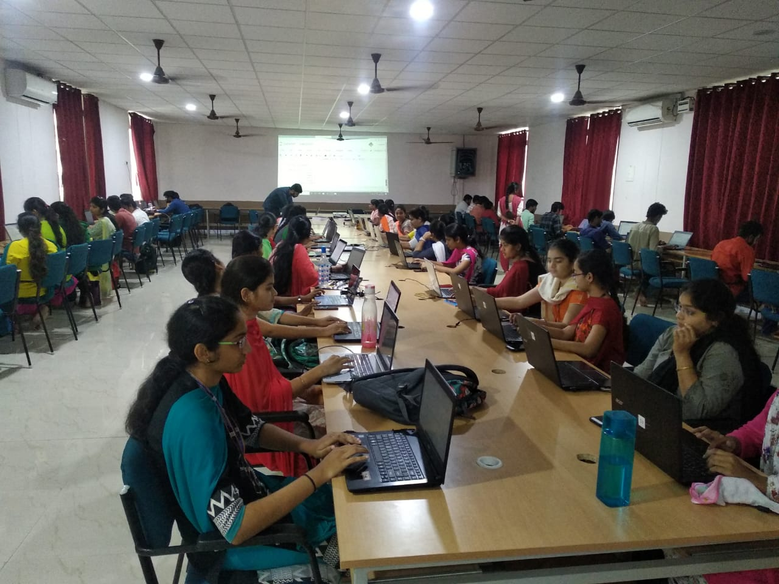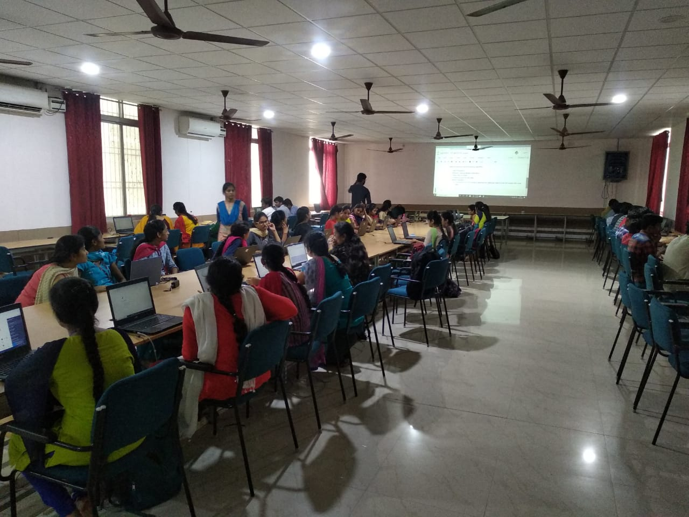

Department of Information Technology::VRSEC
Python using Machine Learning
Registration Form

S.No. | Registration Id | Name | Email | Mobile No
1 | 188W1A1201 | Aakash Lakhyani | aakashlakhyani78@gmail.com | 8328319037
2 | 188W1A1203 | Achanta.Satya Deepika | sathyadeepika0612@gmail.com | 9989998786
3 | 188W1A1204 | Ala Hari Pavan | pavanala13433@gmail.com | 9703672090
4 | 188W1A1205 | Alapati Prem Sai | premsai4249@gmail.com | 8187834249
5 | 188w1a1206 | Anandsai Aluri | anandsai8969@gmail.com | 9618449672
6 | 188W1A1207 | Anumala Hema | anumalahema098@gmail.com | 8186832224
7 | 188W1A1208 | Anvitha Pamidighantam | anvitharavi20@gmail.com | 9441327846
8 | 188W1A1209 | Bharatula Bhanu Sri Vaishnavi | bbsvaishnavi123@gmail.com | 8978484876
9 | 188W1A1210 | Billa Hemanth Venkatesh | hemanthvenkatesh.billa@gmail.com | 9052640212
10 | 188W1A1212 | Borra Harsha | harshaborra28@gmail.com | 7285945255
11 | 188W1A1213 | Burramsetty Sushma Sri | sushmasri7174@gmail.com | 6304013636
12 | 188W1A1214 | Ch.Hampi | chadalavadahampi@gmail.com | 9010342659
13 | 188W1A1215 | Chinni Nagasai Mudgala | nsmudgala2288@gmail.com | 9866681332
14 | 188W1A1216 | D Akhil Reddy | akhil889764@gmail.com | 8897643006
15 | 188W1A1217 | Dudla.V.Joshita Lavanya | lavanyabose123@gmail.com | 6301629193
16 | 188W1A1218 | G.Madhu Priya | madhupriya1082001@gmail.com | 9133612844
17 | 188W1A1219 | Godavarthi Sri Sai Vikas | godavarthivikas@gmail.com | 7995143144
18 | 188W1A1220 | Gonugunta.Nanditha Priya | gnpriya2000@gmail.com | 7013541355
19 | 188W1A1221 | Nagasai Teja | saitejanaidug@gmail.com | 6302850114
20 | 188W1A1222 | Indurthi Deva Kumar | indurthi.devakumar@gmail.com | 6303775523
21 | 188W1A1223 | Injam Sri Latha | injamsrilatha01@gmail.com | 6301614733
22 | 188w1a1225 | Nagaswetha Jeelaga | swethajeelaga29@gmail.com | 9398084177
23 | 188W1A1226 | Jonnalagadda Sai Rashithasree | sairashithasree@gmail.com | 6300705715
24 | 188W1A1227 | Raja Krishna Vamsee | kongarakrishnavamsee@gmail.com | 9346050651
25 | 188W1A1228 | K Manohar Datt | kuchipudimanohar18@gmail.com | 9553241727
26 | 188W1A1229 | K Ravi Kiran | ravikundurthi15@gmail.com | 8179410515
27 | 188W1A1230 | Lanke Sathwik Krishna | lankesathwik7@gmail.com | 9652128787
28 | 188W1A1231 | Mandattil Keeri Snigdha | mksnigdha7778@gmail.com | 9666413271
29 | 188W1A1232 | Morampudi Devi Sowmya | morampudidevisowmya008@gmail.com | 8331899356
30 | 188W1A1233 | Mukku Ramakrishna Reddy | mukkuramakrishna@gmail.com | 9505694645
31 | 188W1A1234 | Nadhella.Naga Chandana | nadhellachandana@gmail.com | 9515029249
32 | 188W1A1235 | Nagella Sankeerthana | vinnynagella@gmail.com | 6281798611
33 | 188W1A1236 | Nallamolu Revanth | revanthn38@gmail.com | 9703316258
34 | 188W1A1237 | Nasaka Ravi Praneeth | nasakapraneeth@gmail.com | 6309789532
35 | 188W1A1238 | Pamarthi Meghana | meghanapamarthimp@gmail.com | 7207376466
36 | 188w1a1240 | Patibandla Surendra Babu | surendrapatibandla44@gmail.com | 9441626205
37 | 188W1A1241 | Podili Venkatesh | Venkatesh.podili2000@gmail.com | 7993292554
38 | 188W1A1242 | Puneet Vallurupalli | puneetvallurupalli1@gmail.com | 9553163222
39 | 188W1A1243 | Raja Ramesh Yarlagaddda | rajarameshy1@gmail.com | 9581176666
40 | 188W1A1244 | Roshini Maddi | roshni.rosey.5924@gmail.com | 9676459646
41 | 188w1a1245 | Aishwarya Edupuganti | aishu14701@gmail.com | 9949494849
42 | 188W1A1246 | Shaik Ahmad Shareef | ahmadshareefapk@gmail.com | 9110380768
43 | 188W1A1247 | S.Yaswanth Bharath | bharathyaswanth2001@gmail.com | 7569269637
44 | 188W1A1248 | S.V.Siva Charan | charansomasila8@gmail.com | 6303276438
45 | 188W1A1249 | S.Siva Rama Krishna | sivaramsurampalli4444@gmail.com | 6303668140
46 | 188w1a1250 | Abdul Amjad | abdulamjad123@gmail.com | 8498962910
47 | 188W1A1251 | Prathyusha Chowdary Tadapaneni | prathyushachowdary1983@gmail.com | 8897605458
48 | 188W1A1252 | Tammisetti Manasa Datta | tammisettidatta@gmail.com | 9492037992
49 | 188W1A1253 | Unnam Mahesh Babu | maheshbabuunnam7013@gmail.com | 7013491765
50 | 188W1A1254 | Uppu Subhanjanaa | subhanjana74@gmail.com | 6302615554
51 | 188W1A1255 | Velagapudi Likhitha | likhithavelagapudi@gmail.com | 9700569999
52 | 188W1A1256 | Vemula Bhargavi | bhargavivemula222@gmail.com | 9949019702
53 | 188W1A1257 | Vijaya Durga Koganti | vijayadurga.k4ever@gmail.com | 6304131315
54 | 188W1A1258 | Vunnam Dharani | dharanivunnam123@gmail.com | 9381145243
55 | 188W1A1259 | Yarramneni Maruthi | maruthi.yarramaneni@gmail.com | 9581438568
56 | 198W5A1201 | Cheekati Sri Lakshmi | srilakshmichowdarychikati@gmail.com | 9848934755
57 | 198W5A1202 | Joga Lokesh Kumar | lokeshkumarjoga009@gmail.com | 9533798579
58 | 198W5A1203 | Sampath Rayudu | sampathraidu025@gmail.com | 7095086708
59 | 198W5A1204 | Muruganvela Sushma | msushma19042001@gmail.com | 7569169297
60 | 198W5A1205 | Nandeti Sravanthi | sravanthinandeti061@gmail.com | 8184977407
61 | 198W5A1206 | Lokeshpappala | lokeshpappala10@gmail.com | 8179988567
62 | 198W5A1207 | Ravuri Naveen Kumar | Chinnukushi141@gmail.com | 6305460193

