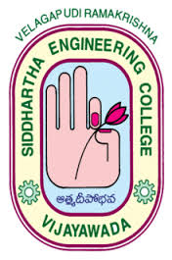
Department of Information Technology

Velagapudi Ramakrishna
Siddhartha Engineering College
(Autonomous, Accredited by NAAC – A Grade)
VIJAYAWADA -7

Report on “Robotics Process Automation”

Department of Information Technology, V.R. Siddhartha Engineering College (Autonomous), Vijayawada – 07 organized Three-Day Workshop on “Robotics Process Automation” from 21-01-2020 to 23-01-2020.

Speakers of the workshop are:

B. Ajay & Naga Babu Automation Anywhere University.

Topics discussed session wise are summarized below:

- What is Robotic Process Automation and how it works?
- Why is the RPA Market Growing so Quickly?
- RPA Implementation Challenges
- RPA Tools and its applications
- The Future of RPA
- Should You Consider RPA?

Participants:

Participants of the workshop are
B.Tech IT students of IIIrd year
Faculty from the Department

Outcomes In summary

- Better accuracy. Robotic Process Automation software robots are programmed to follow rules.
- Improved compliance. Once instructed, RPA robots execute reliably, reducing risk.
- Fast cost savings.
- Super scalable.
- Increased speed and productivity.

Convener
Dr. M. Suneetha, Professor& Head, Department of Information Technology, VRSEC

Co-ordinator
Dr. Ganga Rama Koteswara Rao, Professor

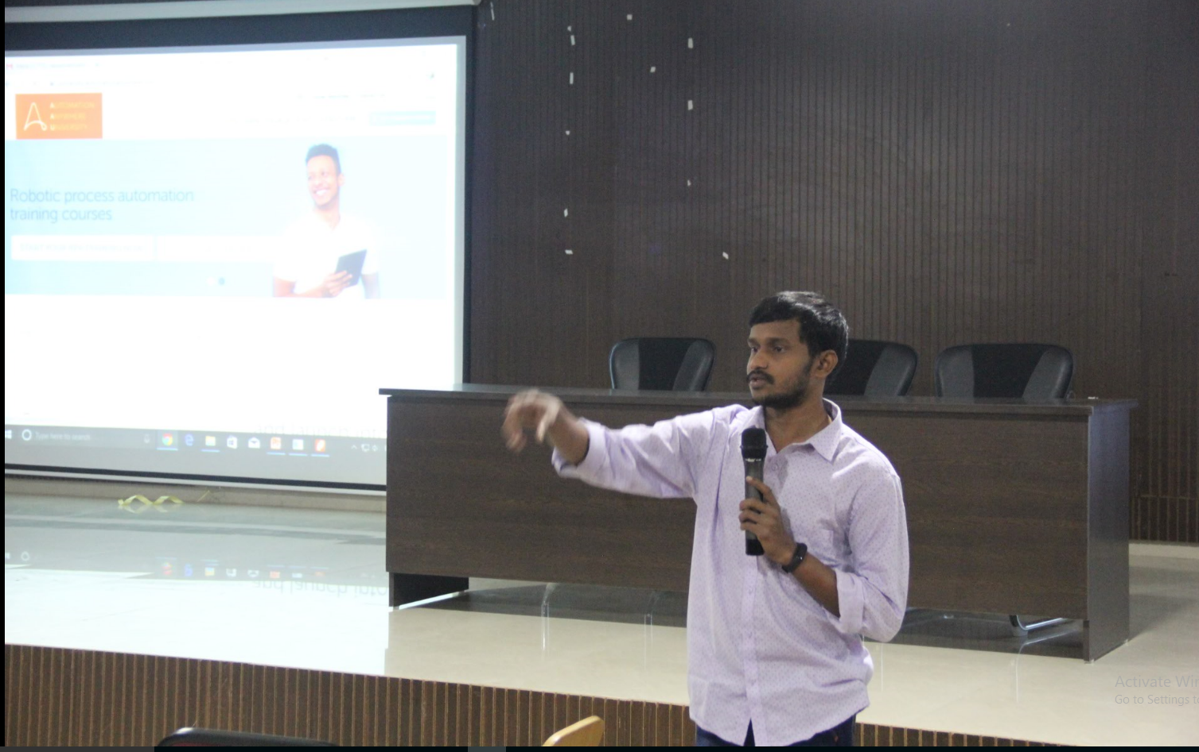

Speaker Delivering the Lecture
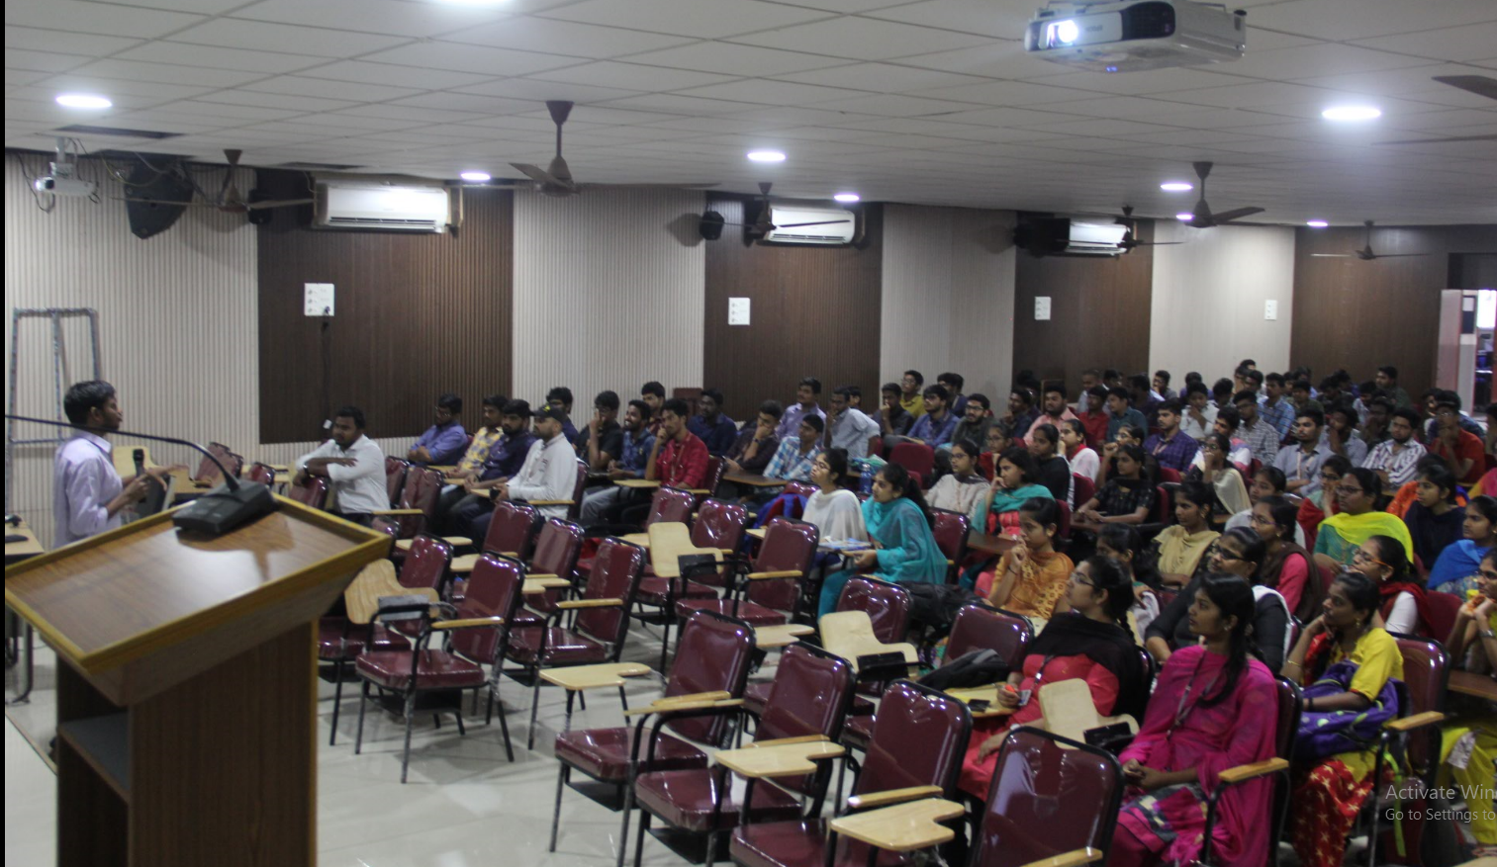

Speaker Delivering the Lecture about RPA Implementation Challenges

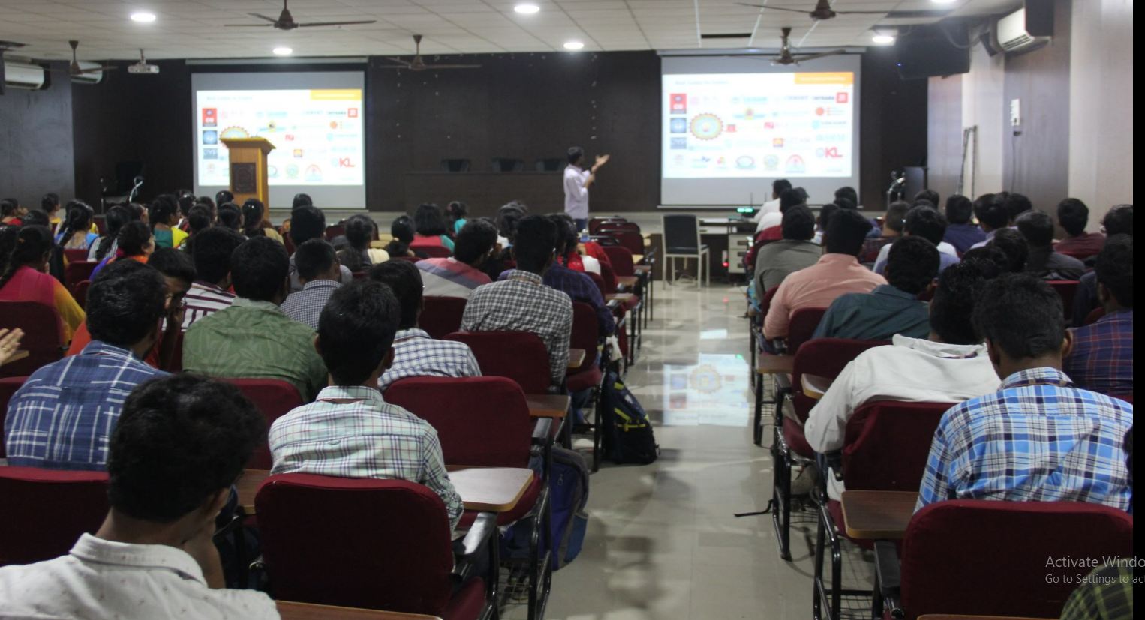

Speaker Delivering about RPA Tools and its applications

