## Report of Faculty Development Programme

## On

## Cyber Security

A five days Faculty development programme (FDP-2020) was successfully conducted online in association with Supraja Technologies and CSI Vijayawada chapter , on 23rd – 27th May 2020 by Department of Information Technology, VRSEC. The FDP programme received an overwhelming response with 286 participants from different regions of India.

Objectives of FDP :

* To impart knowledge on cyber security tools
* To use modern tools for password management, information management
* To safeguard data from hackers

**Date wise brief Report for each of the five days FDP programme is given below with the feedback at the end**

**Date: 23rd May 2020**

The FDP programme was inaugurated in the morning on 23rd May 2020 with few thanks giving session (online) by Dr. M.Suneetha, HOD-IT, VRSEC and Mr.Santhosh Chaluvadi (Resource Person).

In welcome speech, Dr. M.Suneetha, convener of the FDP shared her views with the faculty participants that if faculty wants to develop themselves and their students, then attending such faculty development programmes would enhance their skills of teaching concepts practically in current trends and technologies. She further shared that it helps to improve the performance of faculty in teaching and highlighted the importance and objectives of organizing faculty development programmes. She briefed the participants on the significance of cyber security and its upgrades.

In the second session, resource person Mr. Santhosh Chaluvadi started his discussion with very basic idea of concept of education, learning and teaching. He highlighted the importance of learning cyber security and its latest implementations in our daily life. He shared his knowledge using zoom app with participants using power point presentation and cyber security tools.

In this accordance, Dr.S.Suhasini coordinator of the FDP created the registration form and identified participants list of the FDP programme. To maintain continuous communication with the participants, an whatsapp group is also maintained in two groups. The zoom session links, learning materials, feedback form, online quiz, e-certificates are shared via the groups.

Registration Form: <https://forms.gle/QCttnTGKfbSeLxMd7>

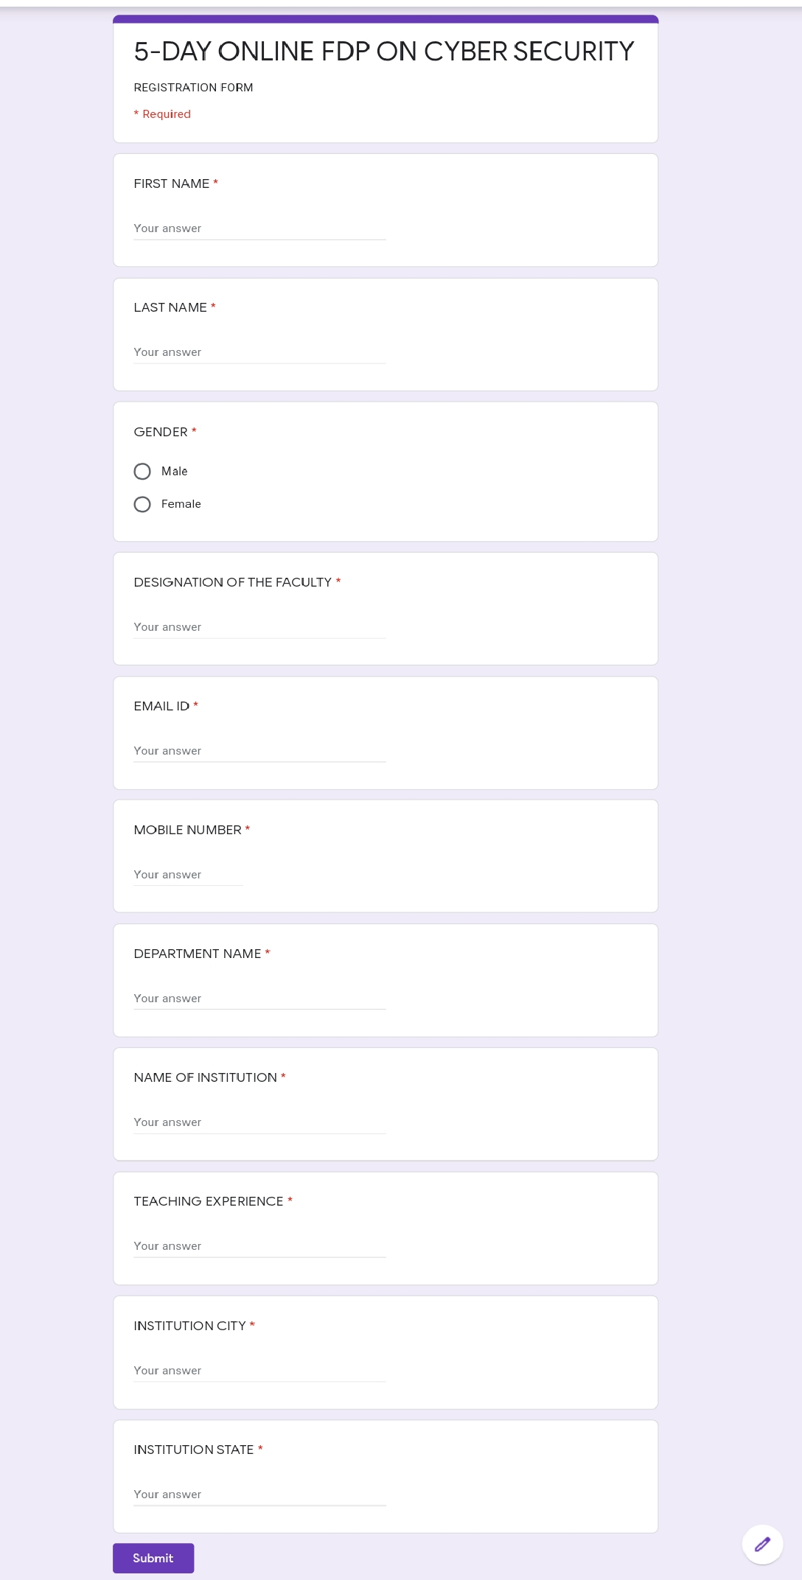

Registration Responses:

<https://drive.google.com/folderview?id=1GneFrWU6icrKj7CO3XRD7sqIEB_zZx2b>

|  |  |  |  |  |  |  |  |  |  |  |  |  |
| --- | --- | --- | --- | --- | --- | --- | --- | --- | --- | --- | --- | --- |
| **S. N O** | **Submit Time** | **1. First Name** | **2. Last name** | **3Gende r** | **4Email ID** | **5Mobile Numb er(pref erably whats app numbe r)** | **6Name of the institu tion** | **7Name of the depart ment** | **8Desig nation** | **9Teachi ng experi ence (in years)** | **10Institu tion city** | **11Institu tion state** |
| 1 | 18 May2020 -03:39PM | Saiku mar | Tara | Male | tarasai kumar @gmai l.com | 9849702404 | CMRTechni cal Campu s | ECE | Associ ate Profes sor | 10 | Hydera bad | TS |
| 2 | 18 May2020 -03:39PM | Butta | Rajase khar | Male | surajb2 000@g mail.co m | 9849128005 | Gudlav alleru Engine ering Colleg e | Electro nics and Comm unicati on Engine ering | Associ ate Profes sor | 20 | Gudlav alleru | Andhra Prades h |
| 3 | 18 May2020 -03:40PM | Dr N | Neelim a | Femal e | gandh amneel u@gm ail.com | 9703059755 | V.R.Siddhart ha Engine ering Colleg e | Inform ation Techn ology | Assista nt Profes sor | 14 | Vijaya wada | Andhra Prades h |
| 4 | 18 May2020 -03:41PM | Donep udi Leela | Dharan i | Femal e | dharan idonep udi@g mail.co m | 9492878422 | PVPSiddha rtha Institut e of Techn ology | Inform ation Techn ology | Asst profess or | 7 | Vijaya wada | Andhra prades h |
| 5 | 18 May2020 -03:41PM | Dr.San deep | Chitte m | Male | sandee pchitte m@gm ail.com | 9949642460 | Rise krishna Sai Gandhi group of instituti ons | Electro nics and commu nicatio ns engine ering | Assista nt profess or | 8 | Ongole | Andhra Prades h |
| 6 | 18 May2020 -03:42PM | Harika | Thalla | Femal e | harikat halla@ aliet.ac.in | 9494093547 | Andhra Loyola institut e of engine ering and technol ogy | Inform ation technol ogy | Assista nt profess or | 3 | Vijaya wada | Andhra Prades h |
| 7 | 18 May2020 -03:42PM | CHAN DU JAGA N SEKH AR | M | Male | mchan dujaga nsekha r@gma il.com | 9440677755 | NS RAJU INSTIT UTE OF TECH NOLO GY | COMP UTER SCIEN CE AND ENGIN EERIN G | Assista nt Profes sor | 14 | VISAK HAPA TNAM | ANDH RA PRAD ESH |
| 8 | 18 May2020 -03:43PM | Deevi | Radha Rani | Femal e | dradha rani29 @gmai l.com | 9676354404 | VFSTRDeeme d to be Univer sity | CSE | Assista nt Profes sor | 15 | Guntur | Andhra Prades h |
| 9 | 18 May2020 -03:44PM | Veera mredd y | Rajase khar | Male | rajasek har.v8 6@gm ail.com | 9704625345 | Rise Krishn a sai Prakas am group of instituti ons | Compu ter scienc e and engine ering | Assista nt profess or | 10 | Ongole | Andhra prades h |
| 10 | 18 May2020 -03:46PM | Madhu Kumar | B P N | Male | bpnma dhuku mar@g mail.co m | 9391552155 | Bonam Venkat a Chala mayya Engine ering Colleg e (A) | CSE | Associ ate Profes sor | 16 | Odalar evu | Andhra Prades h |
| 11 | 18 May2020 -03:46PM | Dr K V V | KUMA R | Male | kumar ece405 @gmai l.com | 9885967006 | Univer sal Colleg e of Engine ering and Techn ology dokipar ru perech arla Guntur | Electro nics and commu nicatio n engine ering | Associ ate Profes sor | 10 | Guntur | Andhra prades h |
| 12 | 18 May2020 -03:47PM | Kusup ati | Naga Koushil Reddy | Male | koushil reddy4 999@g mail.co m | 9494545481 | G.pulla reddy Engine ering Colleg e | ECE | Assista nt profess or | 7 | KURN OOL | Andhra Prades h |
| 13 | 18 May2020 -03:47PM | DASI VENK ATA | SRIHA RI BABU | Male | srihari2 k1@g mail.co m | 9490197730 | G PULLA REDD Y ENGIN EERIN G COLLE GE ( AUTO NOMO US) | Electio ns and commu nicatio n engine ering | Assista nt Profes sor | 15 | Kurnoo l | Andhra Prades h |
| 14 | 18 May2020 -03:48PM | Ganes ha | Divya pranee tha | Femal e | ganesh adivya @gmai l.com | 8919604265 | G.Pulla Reddy engine ering college kurnool | ECE | Assista nt profess or | 5 | Kurnoo l | Andhra prades h |
| 15 | 18 May2020 -03:50PM | Gade | Chandr a Reddy | Male | g.chan drared dy777 @gmai l.com | 9550143823 | Kallam Harana dhared dy institut e of technol ogy | ELectr onics and Comm unicati on Engine ering | Asst prof | 5 | Guntur | Andhra Prades h |
| 16 | 18 May2020 -03:50PM | Muluku tla | Chaita nya | Femal e | muluku tla.chai tanya @gmai l.com | 8500800952 | G.PUL LARE DDY ENGIN EERIN G COLLE GE | ECE | Assista nt profess or | 8 | Kurnoo l | Andhra Prades h |
| 17 | 18 May2020 -03:52PM | Dr.GRajesh | Chandr a | Male | grajesh chandr a@gm ail.com | 9949322620 | SVR ENGIN EERIN G COLLE GE | CSE | Profes sor | 15 | Nandy al | Andhra Prades h |
| 18 | 18 May2020 -03:52PM | Pavan Kumar | Gudipa ti | Male | pavang udipati. 20@g mail.co m | 9618393967 | G.Pulla reddy Engine ering college (Auton omous) | Electro nics and Comm unicati on Engine ering | Assista nt Profes sor | 3 | Kurnoo l | Andhra Prades h |
| 19 | 18 May2020 -03:52PM | V.SATI SH | KUMA R | Male | vsatish.kumar 71@g mail.co m | 9866248428 | Dr.K.V. SUBB A REDD Y COLLE GE OF ENGIN EERIN G FOR WOME N | Compu ter Scienc e and Engine ering | Asst. Profes sor | 6 | KURN OOL | ANDH RA PRAD ESH |
| 20 | 18 May2020 -03:53PM | TATAY YANAI DU | CHAV ATAPA LLI | Male | chtnaid u@gm ail.com | 9493636345 | BONA M VENK ATA CHAL AMAY YA ENGIN EERIN G COLLE GE | Compu ter SCIEN CE AND ENGIN EERIN G | PROG RAMM ER | 0 | Odalar evu | Andhra Prades h |
| 21 | 18 May2020 -03:56PM | MERV A | NAGA MALLI KARJU NA REDD Y | Male | malli51 arjun@ gmail.c om | 9160808859 | SVR ENGIN EERIN G COLLE GE | Compu ter scienc e and Engine ering | Assista nt profess or | 9 | Nandy al | ANDH RAPR ADES H |
| 22 | 18 May2020 -03:57PM | Veerep alli | Ajay Shank ar | Male | ajaysh ankar.v eerepa lli@gm ail.com | 8125633740 | Maline ni Laksh maiah Wome n's Engine ering Colleg e, Pulladi gunta, Guntur | Electro nics and Comm unicati on Engine ering(E CE) | Assista nt Profes sor | 3 | Guntur | Andhra Prades h |
| 23 | 18 May2020 -03:58PM | Vijay kumar | Kamba la | Male | kvkum ar@pv psiddh artha.a c.in | 9493376058 | Prasad VPotluri Siddha rtha Institut e of Techn ology | CSE | Assista nt profess or | 15 | Vijaya wada | Andhra Prades h |
| 24 | 18 May2020 -04:00PM | Ssvr Kumar | Addag arla | Male | ssvrku mar@g vpcdpg c.edu.i n | 9951558839 | Gayatri Vidya Parish ad Colleg e for Degree and PGCourse s (A) | Compu ter Scienc e and Engine ering | Assista nt profess or | 12 | Visakh apatna m | Andhra Prades h |
| 25 | 18 May2020 -04:10PM | Ananth a | Binduk ala | Femal e | binduk alaana ntha@ gmail.c om | 9966355468 | SVREngine ering Colleg e | Compit er Scienc e and Engine ering | Assista nt Profes sor | 5 | Nandy al | Andhra Prades h |
| 26 | 18 May2020 -04:13PM | Tamilk odi | R | Femal e | tamil_k odiin@ yahoo. co.in | 9866383601 | Godav ari Institut e of Engine ering and Techn ology (Auton omous) | MCA | Associ ate profess or | 12 | Rajah mundr y | Andhra prades h |
| 27 | 18 May2020 -04:15PM | C | Rajesw ari | Femal e | rajesw ari.ch @gmai l.com | 8985033011 | G.Pulla reddy engine ering college | Electro nics and commu nicatio n engine ering | Assista nt profess or | 10 | Kurnoo l | Andhra Prades h |
| 28 | 18 May2020 -04:16PM | Mahes h | Babu | Male | gajula mahes hbabu @gmai l.com | 9885739375 | SVRengine ering college | Cse | Assista nt profess or | 8 | Nandy al | Andhra prades h |
| 29 | 18 May2020 -04:18PM | BHAN U PRAK ASH | DOPP ALA | Male | doppal abhan upraka sh@g mail.co m | 9908003894 | VIGNA N’S INSTIT UTE OF INFOR MATIO N TECH NOLO GY(A) | COMP UTER SCIEN CE AND ENGIN EERIN G | ASSIS TANT PROF ESSO R | 11 | VISAK HAPA TNAM | ANDH RA PRAD ESH |
| 30 | 18 May2020 -04:20PM | B | Sweth a | Femal e | swetha.sahan a@gm ail.com | 9492561783 | KSRM COLLE GE OF ENGIN EERIN G (KSRM CE) | Compu ter Scienc e and Engine ering | Assista nt profess or | 8 | Kadap a | Andhra Prades h |
| 31 | 18 May2020 -04:18PM | MADH AVI | KILAR U | Femal e | madha vi.aditi @gmai l.com | 7382654448 | VRSID DHAR THAEngine ering Colleg e | Busine ss Manag ement | Assista nt Profes sor | 12 | Vijaya wada | Andhra Prades h |
| 32 | 18 May2020 -04:24PM | BSN | Murthy | Male | murthy 2007.b@gmai l.com | 9493276456 | BVC ENGIN EERIN G COLLE GE | Compu ter scienc e and ENGIN EERIN G | Associ ate Profes sor | 15 | Odalar evu | Andhra Prades h |
| 33 | 18 May2020 -04:27PM | Dr Dhana Raj | Valluri | Male | drdhan arv@g mail.co m | 9949751703 | BVC ENGIN EERIN G COLLE GE AUTO NOMO US | Electro nics and Comm unicati on Engine ering | Profes sor | 20 | Amala puram | Andhra Prades h |
| 34 | 18 May2020 -04:28PM | KONG ALA | RAJU | Male | harrisr aj99@ gmail.c om | 9908805595 | G PULLA REDD Y ENGIN EERIN G COLLE GE KURN OOL | ECE | Assista nt profess or | 15 | KURN OOL | ANDH RA PRAD ESH |
| 35 | 18 May2020 -04:28PM | ESWA RARA O | BODD EPALL I | Male | eshwar.world @gmai l.com | 9618449991 | Vignan' s Institut e of Inform ation Techn ology (Auton omus) | E.C.E. | Assista nt Profes sor | 10 | Visakh apatna m | And hr a Prades h |
| 36 | 18 May2020 -04:29PM | Rames h | Kompe rla | Male | akomp erla@g mail.co m | 9000330031 | Geico | Billing | Master softwar e engine er | 0 | Usa | Md |
| 37 | 18 May2020 -04:30PM | Thirun avukka rasu | K | Male | thiruna tech@ gmail.c om | 9488466469 | Thanth ai periyar govern ment institut e of technol ogy | Compu ter scienc e and engine ering | Assista nt profess or | 4 | Vellore | Tamiln adu |
| 38 | 18 May2020 -04:31PM | Sarath Chandr a | Banala | Male | sarathit 862@g mail.co m | 9985673669 | Pscmr college of engine ering and technol ogy | Compu ter scienc e and engine ering | Assista nt profess or | 10 | Pscmr college of engine ering and technol ogy | Ap |
| 39 | 18 May2020 -04:35PM | Kotesw ara Rao | Dasari | Male | dkr.nriit @gmai l.com | 8885552793 | NRIInstitut e of Techn ology | CSE | Assoc. Prof | 12 | Guntur | Andhra prades h |
| 40 | 18 May2020 -04:35PM | Ramas wamy | Gonug untla | Male | ramas wamyg rs@gm ail.com | 9248834836 | Maline ni Laksh maiah Wome n's Engine ering Colleg e | CSE | HOD | 22 | Guntur | Andhra Prades h |
| 41 | 18 May2020 -04:39PM | Sridhar | Kavuri | Male | sridhar kavuri @yaho o.com | 9849965036 | P.B.Siddha rtha college of Arts and Scienc e | Compu ter Scienc e | Deputy Head | 23 | Vijaya wada | Andhra Prades h |
| 42 | 18 May2020 -04:39PM | SRI HARI | NALLA MALA | Male | nshari2 011@g mail.co m | 9347337378 | VASIR EDDY VENK ATAD RI INSTIT UTE OF TECH NOLO GY | COMP UTER SCIEN CE AND ENGIN EERIN G | ASSIS TANT PROF ESSO R | 10 | GUNT UR | ANDH RA PRAD ESH |
| 43 | 18 May2020 -04:40PM | Dr.Bin du Madhu ri | Cheek ati | Femal e | chbma dhuri.it @jntuk ucev.a c.in | 9704955762 | JNTUK-Univer sity college of engine ering | Inform ation Techn ology | Assista nt Profes sor | 13 | Viziana garam | Andhra Prades h |
| 44 | 18 May2020 -04:53PM | Adabal a venkat aramte ja | Ramtej a | Male | tejara mteja8 25@g mail.co m | 8374200449 | KKR &KSR INSTIT UTE OF TECH NOLO GY AND SCIEN CES | CSE | Assista nt profess or | 1 | Guntur | Andhra Prades h |
| 45 | 18 May2020 -04:47PM | J | Charis hma | Femal e | magy9 89@g mail.co m | 8125659841 | NBKRI ST | EEE | Assista nt profess or | 3 | Nellore | Andhra prades h |
| 46 | 18 May2020 -04:56PM | BURU JUKOT A | SIVA REDD Y | Male | bsivare ddy123 @gmai l.com | 9652335848 | G PULLA REDD Y ENGIN EERIN G COLLEGE(Aut onomo us) | Electro nics and Comm unicati on Engine ering (ECE) | Assista nt Profes sor | 14 | KURN OOL- | ANDH RA PRAD ESH |
| 47 | 18 May2020 -04:57PM | Uma Mahes h | Ganga varapu | Male | umam aheshg.it@gm ail.com | 9959458976 | Sree Vidyani kethan Engine ering Colleg e | Inform ation Techn ology | Assista nt Profes sor | 12 | Tirupat i | Andhra Prades h |
| 48 | 18 May2020 -05:01PM | JYOTH SNA | V | Femal e | jyothsn a.v@vi dyanik ethan. edu | 9885351458 | Sree Vidyani kethan Engine ering Colleg e | Inform ation Techn ology | Assista nt Profes sor | 16 | Tirupat i | Andhra Prades h |
| 49 | 18 May2020 -05:05PM | DR.L.V ENKA TESW ARA | Reddy | Male | lakkire ddy.v @gmai l.com | 9985533166 | Sree Vidyani kethan Engine ering Colleg e | Inform ation Techn ology | Profes sor | 22 | Tirupat i | Andhra prades h |
| 50 | 18 May2020 -05:13PM | Kotha | Chand ana | Femal e | chanda nakoth a@gm ail.com | 8125112335 | Kkr & ksr institut e of technol ogy and scienc es | Cse | Asst.pr of | 1 | Guntur | Andhra prades h |
| 51 | 18 May2020 -05:16PM | Nallam | Ramak umar | Male | ramak umar4 04@g mail.co m | 9502372632 | Kuppa m engine ering college | ECE | Assista nt profess or | 4 | Kuppa m | Andhra prades h |
| 52 | 18 May2020 -05:16PM | Navee n | Kumar | Male | naveen faith41 0@gm ail.com | 7032823174 | Kuppa m Engine ering Colleg e, Kuppa m | Mecha nical Engine ering | Associ ate Profes sor | 10 | Kuppa m | Andrap radesh |
| 53 | 18 May2020 -05:20PM | SWAR UPA | RANI | Femal e | swarup apvpsit @gmai l.com | 9160804779 | Pvpsit | IT | Assista nt Profes sor | 8 | Vijaya wada | ANDH RA PRAD ESH |
| 54 | 18 May2020 -05:24PM | Dr Manoj | Charde | Male | msc23 41@g mail.co m | 7350555124 | Govern ment Colleg e of Pharm acy, Karad | Pharm acy | Ass Profes sor | 16 | Karad | Mahar ashtra |
| 55 | 18 May2020 -05:28PM | Kiranm ai | Oguri | Femal e | sonyog uri@g mail.co m | 7569448481 | PNC& VIJAYinstitut e of engine ering and technol ogy | Compu ter Scienc e and engine ering | Assista nt profess or | 2 | Phiran gipura m (md),G untur district | Andhra Prades h |
| 56 | 18 May2020 -05:28PM | C NAGA RAJU | KATTA | Male | kattana garaju 77@g mail.co m | 9494913096 | B. V. C ENGIN EERIN G COLLE GE (AUTO NOMO US) - ODAL AREV U | ECE | Assista nt Profes sor | 4 | Amala puram | Andhra prades h |
| 57 | 18 May2020 -05:30PM | BABU S | SELVA RAJ | Male | erbabu.21@g mail.co m | 9994555249 | Kuppa m engine ering college | Compu ter scienc e | Assista nt profess or | 11 | Kuppa m, ANDH RAPR ADES H | ANDH RA PRAD ESH |
| 58 | 18 May2020 -05:31PM | RAMA | NARA SIMHA M KANU KOLLU | Male | kbvram a@gm ail.com | 9640183972 | MAST ER MINDS | IT | IT FACUL TY | 13 | GUNT UR | ANDH RA PRAD ESH |
| 59 | 18 May2020 -05:33PM | Dr Rita | Chakol e | Femal e | kdcritu @gmai l.com | 7350555123 | Govern ment Colleg e of Pharm acy, Karad | Pharm acy | Associ ate Profes sor | 15 | Karad | Mahar ashtra |
| 60 | 18 May2020 -05:35PM | AYYA PPA CHAK RAVA RTHI | M | Male | me.cha kravart y@gm ail.com | 9490798762 | TIRUM ALA ENGIN EERIN G COLLE GE | COMP UTER SCIENCE & ENGIN EERIN G | ASSO CIATE PROF ESSO R | 12 | NARA SARA OPET, GUNT UR DIST | ANDH RA PRAD ESH |
| 61 | 18 May2020 -05:45PM | K.NAGE NDRA | KUMA R | Male | nagen dra.ec e@svr ec.ac | 8008527902 | SVREngine ering Colleg e | ELECT RONIC S AND COMM UNICA TION ENGIN EERIN G | Assista nt profess or | 8 | Nandy al | Andhra Prades h |
| 62 | 19 May2020 -06:15AM | S.ANIL KUMA R | Sikhak olli | Male | sakmb a.k@g mail.co m | 9908565560 | Tiruma la engine ering college | CSE | Asst.pr of | 9 | Narasa raopet | Andhra Prades h |
| 63 | 18 May2020 -05:47PM | Dr Mallap uram Bala | Chenn aiah | Male | chenna i303.m ech@v rsiddha rtha.ac.in | 9059041987 | V.R.Siddha rtha Engine ering Colleg e | Mecha nical Engine ering | Assista nt Profes sor | 12 | Vijaya wada | Andhra Prades h |
| 64 | 18 May2020 -05:49PM | BVenkat a | Suresh Reddy | Male | boddu.l kv@g mail.co m | 9866726291 | Tiruma la Engine ering Colleg e | CSE | Assista nt Profes sor | 8 | Narasa raopet | Andhra Prades h |
| 65 | 18 May2020 -05:55PM | Dr. Senga malase lvi | Jagade esan | Femal e | pavisn eka@g mail.co m | 9445408115 | Sri chandr a sekhar endra sarasw ati viswa mahavi dyalay | Mathe matics | Asst. Profes sor | 15 | Kanchi puram | Tamiln adu |
| 66 | 18 May2020 -05:51PM | Palvadi Sriniva s | Kumar | Male | sriniva skumar palvadi @gmai l.com | 9533678910 | Usha Rama Colleg e of Engine ering and Techn ology | Compu ter Scienc e and Engine ering | Assista nt Profes sor | 1 | Vijaya wada | Andhra Prades h |
| 67 | 18 May2020 -05:57PM | Saibab a | Edhara | Male | amara nath.sa i@gma il.com | 8297039636 | VVIT COLLE GE | Mecha nical engine ering | Assista nt profess or | 1 | Nambu r | Andhra prades h |
| 68 | 18 May2020 -05:58PM | Koruko nda | Manim ala | Femal e | 777ma nimala @gmai l.com | 9573891077 | Usha Rama college of Engine ering and Techn ology,T elaprol u | CSE | Asst.pr of | 3 | Vijaya wada | Andhra prades h |
| 69 | 18 May2020 -05:58PM | Dr E Venu | Madha vi | Femal e | elurive numad havi@ gmail.c om | 9441127829 | Vignan' s Nirula Institut e of Techn ology and Scienc e for Wome n, Guntur | MBA | Head of the Depart ment | 18 | Guntur | AP |
| 70 | 18 May2020 -06:03PM | Laksh mi | Bheem avarap u | Femal e | jlr.laks hmi@g mail.co m | 7893204741 | SVSS CGovern ment Degree Colleg e Sullurp et | Compu ter Scienc e and Applica tions | Lectur er | 2 | Sulluru pet | Andhra Prades h |
| 71 | 18 May2020 -06:09PM | Pavan Kumar | Gonug untla | Male | pavan8 9.gonu guntla @gmai l.com | 8125561665 | Tiruma la engine ering college | Compu ter scienc e and engine ering | Asst profess or | 5 | Narasa raopet | Andhra prades h |
| 72 | 18 May2020 -06:09PM | Sivaku mar | Ponnu samy | Male | drsivak umar.p @gmai l.com | 9790155384 | Sree Vidiyan ikathan Engine ering Colleg e | Inform ation Techn ology | Associ ate Profes sor | 13 | 0 | Andhra Prades h |
| 73 | 18 May2020 -06:11PM | YVishnu | Vardha n | Male | vishnu babu9 876@g mail.co m | 9573398291 | PESUniver sity | Ece | Studen t | 0 | Bangal ore | Karnat aka |
| 74 | 18 May2020 -06:20PM | Swamy | Gundu mogula | Male | swamy 333@g mail.co m | 9393087538 | Bonam venkat a chalam ayya engine ering college odalar evu | Civil engine ering | Associ ate profess or | 7 | Amala puram | Andhra Prades h |
| 75 | 18 May2020 -06:25PM | Prof.V eeraRa ghava Rao | Atukuri | Male | cloud9r ags@g mail.co m | 8978692777 | KKR& KSRInstitut e of Techn ology & Scienc es | CSE | Profes sor | 15 | Guntur | Andhra Prades h |
| 76 | 18 May2020 -06:29PM | Pavitra | H V | Femal e | pavitra hv9@g mail.co m | 7032823174 | Kuppa m Engine ering Colleg e, Kuppa m | Electro nics and Comm unicati on Engine ering | Assista nt Profes sor | 2 | Kuppa m | Andrap radesh |
| 77 | 18 May2020 -06:31PM | VENK ATA SIVA REDD Y | D | Male | dvsrmp l@gma il.com | 9440750445 | BESA NT THEO SOPHI CAL COLLE GE | Compu ter Scienc e | Head | 23 | MADA NAPAL LE | ANDH RA PRAD ESH |
| 78 | 18 May2020 -06:33PM | SHOW RI RAYAL U | BAND ANAD AM | Male | showri @nbkri st.org | 9866561651 | NBKRI ST | CSE | ASSIS TANT PROF ESSO R | 12 | SPSR NELLO RE | ANDH RA PRAD ESH |
| 79 | 18 May2020 -06:35PM | Bandar u | Venkat esh | Male | venky. bandar u@gm ail.com | 9985525981 | Vignan' s Institut e of Inform ation Techn ology (A) | Compu ter Scienc e and Engine ering | Assista nt Profes sor | 13.5 | Duvva da Visakh apatna m | Andhra Prades h |
| 80 | 18 May2020 -06:49PM | Annem needi | Lalshm amara o | Male | lakshm anarao.a@rag hueng gcolleg e.in | 9951060528 | Raghu Engine ering Colleg e | CSE | Assista nt Profes sor | 10 | Visaka patna m | A.P |
| 81 | 18 May2020 -06:54PM | Durvas i | Gudiva da | Femal e | kiran.d urvasi @gmia l.com | 9390825788 | Andhra Loyola Institut e of Engine ering and Techn ology | Inform ation Techn ology | Assista nt Profes sor | 9 | Vijaya wada | Andhra Prades h |
| 82 | 18 May2020 -06:56PM | Dr LAKSH MI PRAS AD | MUDA RAKO LA | Male | lakshm iprasad @nbkri st.org | 8121979497 | NBKRI ST | CSE | Associ ate Profes sor | 11 | Nellore | Andhra Prades h |
| 83 | 18 May2020 -06:57PM | Yamini | Kodali | Femal e | yamini kodali2 5@gm ail.com | 9346465619 | Ushara ma Colleg e of Engine ering and Techn ology | Compu ter Scienc e and Engine ering | Assista nt Profes sor | 9346465619 | Ganna varam | Andhra Prades h |
| 84 | 18 May2020 -06:57PM | K VENK ATAG URUN ATHA | NAIDU | Male | venkat spmvv @gmai l.com | 9030264588 | SoET, SPMV V | CSE | Assista nt Profes sor | 9 | Tirupat i | AP |
| 85 | 18 May2020 -07:00PM | Manne | Sujana | Femal e | sujana m1247@gmai l.com | 7095793174 | NBKRIST,Vid yanaga r | CSE | Assista nt Profes sor | 2 | Nellore | Andhra Prades h |
| 86 | 18 May2020 -07:03PM | KALLA KURI N V P S BRAH MA | RAME SH | Male | rames h.kb17 @gmai l.com | 9676840860 | BVC ENGIN EERIN G COLLE GE | CSE | Asst profess or | 5 | Odalar evu, allavar am(m) | Andhra Prades h |
| 87 | 18 May2020 -07:03PM | LOGE SH | K. | Male | logesh k75@g mail.co m | 9486710565 | Kuppa m Engine ering Colleg e | Compu ter Scienc e & Engine ering | Associ ate Profes sor | 17 | Kuppa m | Andhra Prades h |
| 88 | 18 May2020 -07:06PM | BHAV ANI | V V | Femal e | bhavan i.vanuk urus@ gmail.c om | 9542412004 | USHA RAMA COLLE GE OF ENGIN EERIN G AND TECH NOLO GY | COMP UTER SCIEN CE AND ENGIN EERIN G | Assista nt Profes sor | 3 | VIJAY AWAD A | ANDH RA PRAD ESH |
| 89 | 18 May2020 -07:08PM | P.Sakt hi | Balan | Male | balan1 109@g mail.co m | 9790319916 | Annam alai Univer sity | ECE | Assista nt profess or | 13 | Chida mbara m | Tamiln adu |
| 90 | 18 May2020 -07:10PM | K R | Yadav | Male | kr_yad av1@r ediffma il.com | 9414624536 | GPCKota Rajast han | Compu ter Scienc e | Lectur er | 11 | Kota | Rajast han |
| 91 | 18 May2020 -07:16PM | naveen | jain | Male | naveen @skit. ac.in | 9928795887 | skit,jai pur | IT | asstpro f | 13 | jaipur | rajasth an |
| 92 | 18 May2020 -07:28PM | Kailash | Soni | Male | kailash.soni@ skit.ac. in | 9460066186 | Swami Keshv anand Institut e of Techn ology Manag ement and Gramo than, Jaipur | Compu ter Scienc e and Engine ering | Asst. Prof. | 9 | Jaipur | Rajast han |
| 93 | 18 May2020 -07:30PM | Ragha van | P | Male | raghav an@ps r.edu.i n | 9994524770 | PSREngine ering college | CSE | Assista nt Profes sor | 6 | Sivaka si | Tamil nadu |
| 94 | 18 May2020 -07:37PM | Annam botla | Venkat esh | Male | venki.c se2008 @gmai l.com | 9652443815 | Usha Rama Colleg e of Engine ering and Techn ology | Inform ation Techn ology | Asst Profes sor | 4 | Telapr olu | Andhra Prades h |
| 95 | 18 May2020 -07:38PM | Dr Pooja | Sapra | Femal e | drpooj asapra @gmai l.com | 9582888389 | WCTM | CSE | Prof and head | 16 | Gurugr am | Haryan a |
| 96 | 18 May2020 -07:38PM | Madha v | Sharm a | Male | madha vsharm a36@y ahoo.c o.in | 988783822 | Vit jaipur | Compu ter scienc e | Assista nt profess or | 11 | Jaipur | Rajast han |
| 97 | 18 May2020 -07:38PM | Chetan | Jain | Male | cjcheta n91@g mail.co m | 9460279767 | Apex institut e of engine ering and technol ogy,jai pur | Electric al engine ering | Assista nt profess or | 5 | Jaipur | Rajast han |
| 98 | 18 May2020 -07:43PM | VijayK umar | Selva m | Male | indiani d@gm ail.com | 9894209455 | Bharat hidasa n Univer sity | Compu ter Scienc e and Engine ering | Resear ch Schola r | 0 | Trichy | Tamiln adu |
| 99 | 18 May2020 -07:46PM | Kamal singh | Rao | Male | nobelr ao06@ gmail.c om | 8233268969 | Smcet college phagi Jaipur | Ece | Associ ate profess or | 12 | Jaipur | Rajast han |
| 100 | 18 May2020 -07:46PM | NAKK A | MOUN IKA | Femal e | n.mou nika77 77@g mail.co m | 9652606747 | USHA RAMA COLLE GE OF ENGIN EERIN G AND TECH NOLO GY | CSE | ASSIS TANT PROF ESSO R | 3 | Ganna varam | ANDH RA PRAD ESH |
| 101 | 18 May2020 -07:47PM | Moha mmed | Imran | Male | Imran0 2.md@ gmail.c om | 7416787522 | Andhra loyola institut e of engg & tech | IT | Assista nce Profes sor | 5 | Vijaya wada | AP |
| 102 | 18 May2020 -07:47PM | Guntuk u | Balesw ari | Femal e | g.bales wari@ gmail.c om | 8919916834 | Usha Rama Colleg e of Engine ering and Techn ology | CSE | Assista nt Profes sor | 7 | Vijaya wada | Andhra prades h |
| 103 | 18 May2020 -07:57PM | C V NVara Prasad | Yany | Male | yvvp13 @gmai l.com | 9848399285 | UshaR ama college of engine ering and technol ogy | IT | Associ ate profess or | 10 | Ganna varam | A P |
| 104 | 18 May2020 -07:57PM | Rajend ra | Aaseri | Male | jmsrdjb r@gma il.com | 8054083383 | Govern ment Bangur PGColleg e Didwa na Nagaur | Compu ter Scienc e | Assista nt Profes sor | 8 | Didwa na Nagaur | Rajast han |
| 105 | 18 May2020 -08:01PM | Nikhar | Bhatna gar | Femal e | nikharb hatnag ar@gm ail.com | 6350113869 | Skit | IT | Assista nt Profes sor | 8 | Jaipur | Rajast han |
| 106 | 18 May2020 -08:04PM | Abhish ek | Jain | Male | abhish ekjain. cse@j ecrc.ac.in | 9509881938 | JECR CFound ation | CSE | Asst. Prof. | 10 | Jaipur | Rajast han |
| 107 | 18 May2020 -08:06PM | geerija | lavania | Femal e | girija47 lavania @gmai l.com | 7976196689 | JECR C | CSE | Assista nt profess or | 5 | Jaipur | Rajast han |
| 108 | 18 May2020 -08:08PM | Shikha | Shriva stava | Femal e | shikha shrivas tava.it @jecrc.ac.in | 9636481775 | Jaipur Engg Colleg e and Resear ch centre | Inform ation Techn ology | Asst. Profes sor- | 10 | Jaipur | Rajast han |
| 109 | 18 May2020 -08:12PM | Maddel a | Sailaja | Femal e | sailu.te am@g mail.co m | 8500722564 | PVPSI T | CSE | Asst.Pr ofessor | 10 | Vijaya wada | Andhra Prades h |
| 110 | 18 May2020 -08:11PM | Dr C Kishor Kumar | Reddy C | Male | kishoar 23@g mail.co m | 7386808082 | Stanle y Colleg e of Engine ering and Techn ology for Wome n | CSE | Associ ate Profes sor | 7 | Hydera bad | Telang ana |
| 111 | 18 May2020 -08:15PM | Priyan ka | Nama | Femal e | priyank a.colg @gmai l.com | 7014903139 | SRPGovt Colleg e,Band ikui | Compu ter Scienc e | Assista nt Profes sor | 1 | Dausa | Rajast han |
| 112 | 18 May2020 -08:21PM | ASHO K KUMA R | NAND URI | Male | ashok. onlinec ourse @gmai l.com | 9550206296 | Vignan Nirula Institut e of Techn ology and Scienc e for women,Guntur | CSE | Assista nt profess or | 5 | Guntur | Andhra Prades h |
| 113 | 18 May2020 -08:22PM | Dr. Pankaj | Dadhe ech | Male | pankaj @skit. ac.in | 9887708973 | Swami Keshv anad Institut e of Techn ology, Manag ement & Gramo than (SKIT),Jaipur | Compu ter Scienc e & Engine ering | Associ ate Profes sor & Dy.HOD | 15 | Jaipur | Rajast han |
| 114 | 18 May2020 -08:22PM | RAVIN DRA BABU | KALLA M | Male | rbkalla m2510@gmai l.com | 9440246162 | KITS SINGA PUR | CSE | Profes sor and Head | 21 | Huzura bad | Telang ana |
| 115 | 18 May2020 08:22PM | Shwet a | Saxen a | Femal e | shweta.saxen a20oct @gmai l.com | 9887823279 | Jecrc | Inform ation Techn ology | Assista nt Profes sor | 5.1 | Jaipur | Rajast han |
| 116 | 18 May2020 -08:22PM | SRI VIJAY A | KOND APALL I | Femal e | srivijay ak@g mail.co m | 9160886088 | P V P SIDDH ARTH A INSTIT UTE OF TECH NOLO GY | DEPA RTME NT OF INFOR MATIO N TECH NOLO GY | Assista nt Profes sor | 7.11 | VIJAY AWAD A | ANDH RA PRAD ESH |
| 117 | 18 May2020 -08:24PM | MADA N KUMA R | CHAN DRAN | Male | madan.kumar 547kits w@gm ail.com | 6281814067 | Kakatiy a Institut e of Techn ology and Scienc e Waran gal | Compu ter Scienc e and Engine ering | Assista nt Profes sor | 14 | Waran gal | Telang ana |
| 118 | 18 May2020 -08:28PM | BRAH MAIAH | GAJJA AL | Male | brahm aiahgaj jala@g mail.co m | 7989979697 | SVR ENGIN EERIN G COLLE GE | ECE | Assista nt Profes sor | 4 | Nandy al | AP |
| 119 | 18 May2020 -08:29PM | Sowjan ya | Meka | Femal e | sowjan ya@pv psiddh artha.a c.in | 7729992948 | PVP SIDDH ARTH A INSTIT UTE OF TECH NOLO GY | INFOR MATIV E TECH NOLO GY | ASST PROF ESSO R | 10 | VIJAY AWAD A | ANDH RA PRAD ESH |
| 120 | 18 May2020 -08:45PM | Dr. Ganga dhar Reddy | Ramire ddy | Male | rganga dharre ddy@o utlook. com | 9492993588 | Rajaraj eswari college of engine ering | ECE | Associ ate profess or | 7 | Bengal uru | Karnat aka |
| 121 | 18 May2020 -08:50PM | Vishal Kumar | Sagtan i | Male | vishals agtani @gmai l.com | 8952909950 | M.L.B.Govern ment Colleg e, Nokha (Bikan er) | Compu ter Scienc e | Assista nt Profes sor | 8 | Nokha | Rajast han |
| 122 | 18 May2020 -08:51PM | Dr.NA GASU NDAR AM | SABA PATH Y | Male | naga.s mec@ gmail.c om | 9841277556 | Hindus tan Colleg e of Arts & Scienc e | Compu ter Scienc e | Associ ate Profes sor | 15 | Chenn ai | Tamil Nadu |
| 123 | 18 May2020 -08:53PM | Dr. Mahen dra Singh | Yadav | Male | mahsin yad18 @gmai l.com | 7340303694 | Pragati Private Industri al Trainin g Center, Rajgar h, Alwar (Rajast han) | CSE | Princip al | 4 | Rajgar h | Rajast han |
| 124 | 18 May2020 -09:04PM | Anjali | Pande y | Femal e | njl27pa ndey@ gmail.c om | 9414330982 | Swami Keshv anand Institut e of Techn ology, Manag ement & Gramo than | Inform ation Techn ology | Assista nt Profes sor | 9 | Jaipur | Rajast han |
| 125 | 18 May2020 -09:25PM | Dr Moha med Yacoa b | M Y | Male | yacoab @yaho o.com | 9600039078 | The new college chenna i | Inform ation technol ogy | Assista nt profess or | 20 | Chenn ai | Tamiln adu |
| 126 | 18 May2020 -09:07PM | ENUG ULA | HARIK RISHN A | Male | hari.e.k rishna @gmai l.com | 917761139 | Vaagd evi Engine ering Colleg e | Compu ter scienc e and engine ering | Assista nt profess or | 8 | Waran gal | Telang ana |
| 127 | 18 May2020 -09:13PM | Dr.MO HAME D MUST AQ AHME D | A | Male | mmmu staq@ gmail.c om | 7358400393 | Moha med Sathak Colleg e of Arts and Scienc e | Compu ter scienc e depart ment | Assista nt Profes sor | 15 | Chenn ai | Tamiln adu |
| 128 | 18 May2020 -09:17PM | Gujjula | Deepa k | Male | gujjula deepak @gmai l.com | 9966554744 | Kamal a Institut e of Techn ology and Scienc e | Compu ter Scienc e and Engine ering | Assista nt Profes sor | 5 | Huzura bad | Telang ana |
| 129 | 18 May2020 -09:32PM | Kusum | Yadav | Femal e | kusum yadav.i t@jecr c.ac.in | 9024639556 | JECR CJaipur | Inform ation technol ogy | Assista nt profess or | 10 | Jaipur | Rajast han |
| 130 | 18 May2020 -09:42PM | Priyan ka | Sharm a | Femal e | Priyan ka0829 1@gm ail.com | 8890606912 | SKIT | CS | Assista nt Profes sor | 7.2 | Jaipur | Rajast han |
| 131 | 18 May2020 -09:42PM | BASH EER | AHAM ED A | Male | abam mb2@ gmail.c om | 9865485833 | Jamal Moha med Colleg e | Compu ter Scienc e | Assista nt Profes sor | 15 | Trichy | Tamiln adu |
| 132 | 18 May2020 -09:48PM | Dr KART HIKEY AN | B | Male | bkarthi keyanp hd@g mail.co m | 9443998004 | Bishop Heber Colleg e | Compu ter Scienc e | Assista nt Profes sor | 15 | Trichy | Autono mous |
| 133 | 18 May2020 -09:49PM | Srilath a | Kolukul uri | Femal e | ksrilath a@sta nley.ed u.in | 9553907562 | Stanle y college of Engine ering and technol ogy For women | Compu ter scienc e | Assista nt profess or | 4 | Hydera bad | Telang ana |
| 134 | 18 May2020 -09:54PM | Revath i | Issarap u | Femal e | revathi. issarap u@gm ail.com | 9885866004 | VVIT,Nambur | EEE | Assista nt profess or | 2 | Guntur | Andhra Prades h |
| 135 | 18 May2020 -09:58PM | Mr. DHUP AM ARUN | KUMA R | Male | arunrs 9848@gmail.c om | 8985876893 | RAGH U INSTIT UTE OF TECH NOLO GY (AUTO NOMO US),D AKAM ARRI, VISAK HAPA TNAM | ELECT RONIC S AND COMM UNICA TION ENGIN EERIN G | ASSIS TANT PROF ESSO R | 10 | VISAK HAPA TNAM | ANDH RA PRAD ESH |
| 136 | 18 May2020 -10:01PM | K. | AMAR ENDR ANAT H | Male | amare ndrana th.cse @svre c.ac.in | 9502777713 | SVR ENGIN EERIN G COLLE GE | COMP UTER SCIEN CE AND ENGIN EERIN G | ASSIS TANT PROF ESSO R | 8 | NAND YAL | ANDH RA PRAD ESH |
| 137 | 18 May2020 -10:08PM | Gavini | Sreelat ha | Femal e | gsreela tha@st anley.e du.in | 9866514462 | Stanle y Colleg e of Engine ering and Techn ology for Wome n | Inform ation Techn ology | Assista nt Profes sor | 10 | Hydera bad | Telang ana |
| 138 | 18 May2020 -10:08PM | Dr. Vivek Kumar | Jain | Male | vivek.j ain129 @gmai l.com | 8824670200 | Biyani Girls Colleg e Jaipur | Physic s | Assista nt Profes sor | 10 | Jaipur | Rajast han |
| 139 | 18 May2020 -10:12PM | Archan a | Jain | Femal e | archan ajain.rb t@gma il.com | 7877012220 | Swami Keshw anand Institut e of Techn ology Manag ement and Gramo than Jaipur | Electro nics and Comm unicati on Engine ering | Resear ch Studen t | 2 | Jaipur | Rajast han |
| 140 | 18 May2020 -10:13PM | Pushp a Rajita | Waring | Femal e | rajita.st martins @gmai l.com | 9371860174 | Ushara ma college of engine ering and technol ogy | CSE | Assista nt Profes sor | 6 | Telapr olu | Andhra Prades h |
| 141 | 18 May2020 10:14PM | Suthen dran | Kanna n | Male | k.suthe ndran @klu.a c.in | 9043871621 | Kalasal ingam Acade my of Resear ch and Educat ion | Inform ation Techn ology | Associ ate Profes sor & Head | 17 | Krishn ankoil | Tamiln adu |
| 142 | 18 May2020 -10:15PM | Radhik a | Rajoju | Femal e | radhika.manu 223@g mail.co m | 9652026925 | Kamal a Institut e of Techn ology and Scienc e | Compu ter Scienc e and Engine ering | Assista nt Profes sor | 12 | Singap uram Huzura bad | Telang ana |
| 143 | 18 May2020 -10:17PM | KANC HERL A | BALA KRISH NA | Male | balay.k ancherl a@gm ail.com | 8328512797 | NRIIT | CSE | ASSO CIATE PROF ESSO R | 13 | GUNT UR | ANDH RA PRAD ESH |
| 144 | 18 May2020 -10:20PM | Ajay | Khunte ta | Male | khuteta ajay@ poorni ma.org | 9828596101 | Poorni ma Colleg e of engine ering Jaipur | Compu ter | Profes sor | 10 | Jaipur | Rajast han |
| 145 | 18 May2020 -10:25PM | Nimish | Arvind | Male | nimish. arvind @poor nima.o rg | 8696857545 | Poorni ma Colleg e Of Engine ering | Compu ter Scienc e | Assista nt Profes sor | 13 | Jaipur | Rajast han |
| 146 | 18 May2020 -10:25PM | Sanjay | Bharga va | Male | sanjay bharga va78@ gmail.c om | 9521618370 | Poorni ma college of engine ering | CSE | Profes sor | 22 | Jaipur | Rajast han |
| 147 | 18 May2020 -10:27PM | SUBB A REDD Y | THUM U | Male | subbar eddy.th umu@ gmail.c om | 9701614212 | Tiruma la Engine ering Colleg e | CSE | Assista nt Profes sor | 7 | Narasa raopet, Guntur | Andhra Prades h |
| 148 | 18 May2020 -10:33PM | Dr. Hemal atha | Senthil mahes h | Femal e | Pithem alatha @gmai l.com | 9840337793 | Panim alar Institut e of Techn ology | CSE | Profes sor | 19 | Chenn ai | Tamil nadu |
| 149 | 18 May2020 -10:33PM | DANG ETI | SATIS H | Male | satishd jntu@g mail.co m | 9949412230 | SWAR NAND HRA COLLE GE OF ENGIN EERIN G AND TECH NOLO GY | CIVIL ENGIN EERIN G | ASSIS TANT PROF ESSO R | 6 | NARA SAPU R | ANDH RA PRAD ESH |
| 150 | 18 May2020 -10:45PM | CHAN DRA MAHE SH | BOBB URI | Male | chandr amahe sh_bob buri@s rmap.e du.in | 8332839289 | SRMAmara vathi | CSE | Studen t | 0 | Amara vathi | ANDH RA PRAD ESH |
| 151 | 18 May2020 -10:46PM | MOHA MED | MUSH TAFA A | Male | moha medm ushtafa @gmai l.com | 8110989943 | JAMAL MOHA MED COLLE GE | INFOR MATIO N TECH NOLOGY / BSC(cs) | STUD ENT | 0 | TRICH Y | TAMIL NADU |
| 152 | 18 May2020 -10:52PM | Manish | Sharm a | Male | manu1 3raj@g mail.co m | 9530014613 | Depart ment of Inform ation Techn ology and Comm unicati on, Govern ment of Rajast han | Depart ment of Inform ation Techn ology and Comm unicati on, Govern ment of Rajast han | IA | 5 | Jaipur | Rajast han |
| 153 | 18 May2020 -10:55PM | NEER AJ | GARG | Male | ng23n eeraj.g arg@g mail.co m | 8890858110 | SKIT JAIPU R RAJAS THAN | CSE | ASSIS TANT PROF ESSO R | 9 | JAIPU R | RAJAS THAN |
| 154 | 18 May2020 10:57PM | Ragha vendra | K.C | Male | raghav endra0 451@g mail.co m | 8297492112 | G.Pulla Reddy Engine ering Colleg e | ECE | Assista nt profess or | 0.66 | Kurnoo l | Andhra Prades h |
| 155 | 18 May2020 -10:57PM | Mangai yarkar asi | Ganes amoort hy | Femal e | mangai mca20 06@g mail.co m | 9952286644 | K.S.Rangasa my Colleg e of Arts and Scienc e (Auton omous),Tiruch engod e | Compu ter Applica tions | Assista nt Profes sor | 9 | Salem | TamilN adu |
| 156 | 18 May2020 -11:01PM | Palika | Jajoo | Femal e | palikaj ajoo@ gmail.c om | 9414499507 | Swami Keshv anand Institut e of Techn ology , Manag ement and Gramo than | Compu ter Scienc e | Assista nt Profes sor | 9 | Jaipur | Rajast han |
| 157 | 18 May2020 -11:01PM | Umam ahesw ari | Balam urugan | Femal e | baluma 78@g mail.co m | 7014199072 | JECR C | CSE | Asst. Prof | 10 | Jaipur | Rajast han |
| 158 | 18 May2020 -11:06PM | Sundar esan | M | Male | bu.sun daresa n@gm ail.com | 9443042340 | Bharat hiar Univer sity | Inform ation Techn ology | Profes sor and Head | 35 | Coimb atore | Tamiln adu |
| 159 | 18 May2020 -11:08PM | Vivek | Sharm a | Male | vivek.s harma @gitjai pur.co m | 8952013001 | GIT,Jaipur | CSE | Assista nt Profes sor | 11 | Jaipur | Rajast han |
| 160 | 18 May2020 -11:14PM | MALA THI | R | Femal e | shamal u2010@gmai l.com | 9791755884 | H. H. THE RAJAH 'S COLLE GE | COMP UTER SCIEN CE | ASSIS TANT PROF ESSO R | 22 | PUDU KKOT TAI | TAMIL NADU |
| 161 | 18 May2020 -11:19PM | Abdul Rahma n | M | Male | rahma ntpr98 @gmai l.com | 9944589458 | Jamal moha med college | Bsc cs | Develo p my career | 0 | Trichy | Tamil nadu |
| 162 | 18 May2020 -11:27PM | Dr. Moha med Bashe er | K.P | Male | mbash eerkp @gmai l.com | 9633913396 | SSColleg e Areeko de | Compu ter Scienc e | Asst. Profes sor | 18 | Areeko de | Kerala |
| 163 | 18 May2020 -11:34PM | VIKAS | VERM A | Male | vikasv erma1 988@g mail.co m | 8560892481 | Jaipur Nation al Univer sity | CSE | Asst. Profes sor | 8 | Jaipur | Rajast han |
| 164 | 18 May2020 -11:49PM | SURE SH THAN GAKRI SHNA N | M | Male | suresh. nellai @gmai l.com | 8807721145 | Einstei n college of engine ering | CSE | Assista nt Profes sor | 14 | Tirunel veli | Tamil Nadu |
| 165 | 19 May2020 -12:03AM | Vikram Kumar | Pingili | Male | vikram bhayya @gmai l.com | 8331926163 | Not applica ble | Ece | Scienc e commu nicator | 3.5 | Not applica ble | Not applica ble |
| 166 | 19 May2020 -12:29AM | Puliche rla | Siva Prasad | Male | prasad siva_1 7@yah oo.com | 9866093651 | RVR&J C COLLE GE OF ENGIN EERIN G | CSE | Assista nt Profes sor | 19 | Guntur | Andhra Prades h |
| 167 | 19 May2020 -01:44AM | Dr Kanak a Durga | A | Femal e | durgap allavi@ gmail.c om | 9849384247 | Stanle y Colleg e of Engine ering and Techn ology for Wome n | Inform ation Techn ology | Prof. and HOD IT | 18.6 | HYDE RABA D | Telang ana |
| 168 | 19 May2020 -06:04AM | Dr. SYED IBRAH IM | KALIB A | Male | syedibr ahimka liba@g mail.co m | 9894625144 | IP SOFT WARE SOLU TION, COIMB ATOR E-09. | COMP UTER SCIEN CE | SENIO R NETW ORK INSTR UCTO R | 19 | COIMB ATOR E | TAMIL NADU |
| 169 | 19 May2020 -06:09AM | Dr.K.B. S. | SAST RY | Male | sastryk bs@g mail.co m | 9492525250 | Andhra Loyola Colleg e | Compu ter scienc e | Associ ate profess or | 29 | Vijaya wada | Andhra Prades h |
| 170 | 19 May2020 -06:23AM | Dr.Ch. Rajesw ari | Rajesw ari | Femal e | rajesw ariv930 @gmai l.com | 9490020100 | PB.Sidd hartha Colleg e of Arts and Scienc e | Place ments | Lectur er | 7 | Vijaya wada | Andhra Prades h |
| 171 | 19 May2020 -06:30AM | Sande ep | T | Male | tsande ep@st anley.e du.in | 9849912715 | Stanle y Colleg e of Engine ering and Techn ology for Wome n | Inform ation Techn ology | Assista nt Profes sor | 13 | Hydera bad | Telang ana |
| 172 | 19 May2020 -06:30AM | SIVA KRISH NA | TEKI | Male | siva_te ki@red iffmail. com | 9908956763 | PB SIDDH ARTH A COLLE GE OF ARTS AND SCIEN CE | MATH EMATI CS | ASSIS TANT PROF ESSO R | 13 | VIJAY AWAD A | ANDH RA PRAD ESH |
| 173 | 19 May2020 -06:55AM | Ashok Kumar | A | Male | ashoka mjuno @rediff mail.co m | 9786271855 | Alagap pa Govt. Arts Colleg e, Karaik udi | Compu ter Scienc e | Assista nt Profes sor | 23 | Karaik udi | Tamiln adu |
| 174 | 19 May2020 -07:16AM | S. SIVA NAGA | LAKSH MI | Femal e | snlaks hmi198 5@gm ail.com | 9703315452 | P B SIDDH ARTH A COLLE GE OF ARTS AND SCIEN CE, VIJAY AWAD A | MATH EMATI CS | LECTU RER | 12 | Vijaya wada | Andhra prades h |
| 175 | 19 May2020 -07:27AM | Kanum ala | Rajya lakshm i | Femal e | raji.kan umala @gmai l.com | 9493929314 | A. G&S. G Siddha rtha degree college of vuyyur u | Mathe matics | Lectur er | 3 | Vuyyur u | Andhra prades h |
| 176 | 19 May2020 -07:31AM | VEMU RU | GOPIC HAND | Male | vemur u.gc@ gmail.c om | 9966518888 | AG & SG SIDDH ARTH A DEGR EE COLLE GE | Comm erce | Lectur er | 14 | Vuyyur u | Andhra Prades h |
| 177 | 19 May2020 -07:32AM | Santho sh | G | Male | gotla.s anthos h@gm ail.com | 7013470289 | Siddha rth institut e of technol ogy and scienc e | ELECT RICAL AND ELECT RONIC ENGIN EERIN G | Assista nt profess or | 2 | Hydera bad | Telang ana |
| 178 | 19 May2020 -07:33AM | Thota | Naga Prasad a Rao | Male | t.naga prasad arao@ gmail.c om | 9866803938 | A.G& S.GSiddha rtha Colleg e of Arts&S cience | Compu ter Scienc e | Head of the Depart ment | 12 | Vuyyur u | Andhra Prades h |
| 179 | 19 May2020 -07:41AM | Rubal Deep | Gill | Femal e | rubal@ skit.ac. in | 9887441103 | SKIT | CSE | Associ ate Prof. | 11 | Jaipur | Rajast han |
| 180 | 19 May2020 -07:42AM | Dr. J.Suneet ha | Rani | Femal e | suneet hamet @gmai l.com | 9885119586 | P. B. Siddha rtha Colleg e of Arts&S cience, Vijaya wada | Physic s | Lectur er | 21 | Vijaya wada | Andhra Prades h |
| 181 | 19 May2020 -08:14AM | A. N V Durga | Anupa ma | Femal e | nvdurg aanup amaall e@gm ail.com | 9949017195 | P.B.Siddhart ha Colleg e of Arts and Scienc e | Comm erce | Lectur er 8 | 8 | Vijaya wada | Andhra Prades h |
| 182 | 19 May2020 -08:34AM | KUMA RA SWAM Y | BEJJA NKI | Male | kumar aswam yb@st marysg roup.c om | 9492457155 | St Mary's Engine ering Colleg e | Compu ter scienc e and engine ering | Assista nt profess or | 10 | Hydera bad | Telang ana |
| 183 | 19 May2020 -08:35AM | Ravi shanke r | Dubey | Male | ravimat h13@g mail.co m | 9829009476 | Amity univers ity jaipur | Mathe matics | Assista nt profess or | 15 | Jaipur | Jaipur |
| 184 | 19 May2020 -08:39AM | Mastan | vali | Male | dmasta nvali69 5@gm ail.com | 9441115950 | J.B.Institut e of Engine ering & Techn ology | Inform ation Techn ology | Assista nt Profes sor | 8 | Hydera bad | Telang ana |
| 185 | 19 May2020 -08:45AM | Ch.siv a | Santho sh | Male | sivasa nthosh asdra @gmai l.com | 8555899257 | Vignan Institut e of inform ation technol ogy | Electro nics&c ommu nicatio n engine ering | Studen t | 0 | Visakh apatna m | Andhra prades h |
| 186 | 19 May2020 -08:50AM | T.Sarath | Babu | Male | sarath. thotap alli@g mail.co m | 9989252408 | G.Pulla Reddy Engine ering Colleg e | ECE | Assista nt Profes sor | 13 | Kurnoo l | -Andhra Prades h |
| 187 | 19 May2020 -08:59AM | Guru Prasad | Pasum arthi | Male | Gurupr asadm bahr@ gmail.c om | 8686208686 | PBSiddha rtha Arts and Scienc e Colleg e, Vijaya wada | BBA BA | Assista nt Profes sor | 12 | Vijaya wada | Andhra Prades h |
| 188 | 19 May2020 -09:25AM | Venu Gopal | Gadda m | Male | venugo pal.gad dam@ gmail.c om | 9030384598 | P V PSiddha rtha Institut e of Techn ology | Inform ation Techn ology | Asst. Prof. | 13.6 | Vijaya wada | Andhra prades h |
| 189 | 19 May2020 -09:30AM | Mamat ha | R | Femal e | mamat har@k sit.edu. in | 8095666687 | K SInstitut e of Techn ology | Compu ter Scienc e and Engine ering | Assista nt Profes sor | 12 | Bangal ore | Karnat aka |
| 190 | 19 May2020 -09:38AM | veerla | Nagam allesw araRao | Male | nagam alliv14 @gmai l.com | 9505582600 | AG & SG SIDDH ARTH A DEGR EE COLLE GE VUYY URU | COMP UTER S | LECTU RER | 4 | VUYY URU | ANDH RA PRAD ESH |
| 191 | 19 May2020 -09:39AM | Sriniva sa | Reddy | Male | kondas reenu @gmai l.com | 9849024285 | IARE | IT | PROF ESSO R | 15 | Hydera bad | Telang ana |
| 192 | 19 May2020 -09:42AM | Sunil | Adama ne | Male | adman esunil @gmai l.com | 9096370855 | Sunbe am | Etc | Embed ded system engine er | 1 | Pune | Mahar astra |
| 193 | 19 May2020 -09:50AM | RAJAN KUMA R | JHA | Male | rajanjh a.cse @jecrc.ac.in | 8233989962 | JAIPU R ENGIN EERIN G COLLEGE & RESE ARCH CENT RE JAIPU R | COMP UTER SCIENCE & ENGIN EERIN G | ASSIS TANT PROF ESSO R | 10 | JAIPU R | RAJAS THAN |
| 194 | 19 May2020 -09:52AM | SUND ARAB ABU | MADD U | Male | sundar 539@g mail.co m | 9885404221 | PVPSiddha rth Institut e of Techn ology | IT | Assista nt profess or | 9 | Vijaya wada | Andhra Prades h |
| 195 | 19 May2020 -09:55AM | Raghu Nanda n | Singh Hada | Male | raghu. hada1 08@g mail.co m | 9887528397 | Stani memor ial college of engine ering and technol ogy jaipur | Electric al engine ering | Assista nt profess or | 6 | Jaipur | Rajast han |
| 196 | 19 May2020 -10:02AM | Anitha | Thokal a | Femal e | tanitha. nov26 @gmai l.com | 7680866717 | ISLEngine ering Colleg e | Compu ter Scienc e and Engine ering | Assista nt Profes sor | 10 | Hydera bad | Telang ana |
| 197 | 19 May2020 -10:07AM | Suloch ana | P | Femal e | suloch anadoll y50@g mail.co m | 9381564093 | Pallavi engine ering college | Human ities and scienc es | Assista nt profess or | 4 | Hydera bad | Telang ana |
| 198 | 19 May2020 -10:08AM | Ratna m | Dodda | Male | ratnam.dodda @gmai l.com | 9985247447 | Govern ment Colleg e of Engine ering,K alahan di | Compu ter Scienc e & Nginee ring | Assista nt Profes sor | 11 | Bhawa nipatna | Odisha |
| 199 | 19 May2020 -10:13AM | Satholi | Mahes h | Male | mahes h1203.satholi @gmai l.com | 7893101609 | Pallavi engine ering college | Mecha nical engine ering | Assista nt profess or | 5 | Hydera bad | Telang ana |
| 200 | 19 May2020 -10:13AM | Abhilas ha | . | Femal e | abhilas ha.cse @jecrc.ac.in | 9587564564 | JECR CEngine ering Colleg e And Resear ch Centre | CSE | Assista nt profess or | 6 | Jaipur | Rajast han |
| 201 | 19 May2020 -10:15AM | Dr | GLaksh mi | Femal e | lakshm ineeraj a@gm ail.com | 9494767015 | PVP SIDDH ARTH A INSTIT UTE OF TECH NOLO GY | Inform ation Techn ology | Assista nt Profes sor | 10 | Vijaya wada | Andhra Prades h |
| 202 | 19 May2020 -10:16AM | Nellipu di | Rajesw ari | Femal e | nellipu dirajes wari.m @gmai l.com | 8367360283 | Pallavi engine ering college | H&S | Assista nt profess or | 7 | Hydera bad | Telang ana |
| 203 | 19 May2020 -10:23AM | Souga ndhika | Naraya n | Femal e | sougan dhikan arayan @ksit. edu.in | 9880285886 | K.S.Institut e of Techn ology | Compu ter Scienc e and Engine ering | Assista nt Profes sor | 15 | Bangal ore | Karnat aka |
| 204 | 19 May2020 -10:36AM | Hanum antha Rao | Goutha m | Male | hanuch anti1@ gmail.c om | 9000815895 | Gayatri Vidya Parish ad Colleg e for Degree and PGCourse s(A) | Depart ment of Compu ter Applica tions | Assista nt Profes sor | 12 | Visakh apatna m | Andhra Prades h |
| 205 | 19 May2020 -10:42AM | Pallavi | I.S | Femal e | ipallavi @yaho o.com | 9666105272 | Gayatri Vidya Parish ad Colleg e for Degree and PGCourse s(A) | Depart ment of Compu ter Applica tions | Profes sor | 18 | Visakh apatna m | Andhra Prades h |
| 206 | 19 May2020 -10:43AM | BURR A | PHANI KRISH NA | Male | phanikr ishnas arma@ gmail.c om | 8143375795 | PBSiddha rtha Colleg e of Arts & Scienc e | Comm erce | Lectur er | 2 | Vijaya wada | Andhra Prades h |
| 207 | 19 May2020 -10:48AM | SNEHa | C R | Femal e | snehac r@ksit. edu.in | 9980065157 | KSIT | Compu ter Scienc e and Engine ering | Assista nt Profes sor | 8 | Bangal ore | Karnat aka |
| 208 | 19 May2020 -10:57AM | Shank er | Chandr e | Male | shanke r.chan dre@g mail.co m | 9848013862 | Anurag Colleg e of engine ering | CSE | Assista nt profess or | 12 | Hydera bad | Telang ana |
| 209 | 19 May2020 -11:10AM | Samrat Krishn a | Gadda m | Male | samrat krishna gadda m@gm ail.com | 9177937461 | P.B.SI DDHA RTHA COLLE GE OF ARTS AND SCIEN CE | Compu ter Scienc e | Assista nt Profes sor | 10 | Vijaya wada | Andhra Prades h |
| 210 | 19 May2020 -11:12AM | Santos h | Singh | Male | drsant osh.it @jecrc.ac.in | 9829813220 | Jaipur Engine ering Colleg e & Resear ch Centre | Electro nics and Comm unicati on Engine ering | Profes sor | 25 | Jaipur | Rajast han |
| 211 | 19 May2020 -11:18AM | KURA PATI | SUBB A REDD Y | Male | kurapa tisr999 @gmai l.com | 9848248923 | PRAK ASAM ENGIN EERIN G COLLE GE | INFOR MATIO N TECH NOLO GY | ASSO CIATE PROF ESSO R | 19 | KAND UKUR | AP |
| 212 | 19 May2020 -11:28AM | vandan a | Lingam pally | Femal e | vandan akiran.l ingamp ally@g mail.co m | 9010667416 | Nalla Narasi mha Reddy educati on society' s group of instituti ons | CSE | Asst.Pr of | 9 | Hydera bad | Teleng ana |
| 213 | 19 May2020 -11:32AM | DR. RAJES H KUMA R | BATHI JA | Male | rajesh. ece@j ecrc.ac.in | 9414399891 | JECR C, JAIPU R | ECE | ASSO CIATE PROF ESSO R | 21 | JAIPU R | RAJAS THAN |
| 214 | 19 May2020 -11:36AM | ANUR ADHA | TUTIK A | Femal e | anurad ha.rec @gmai l.com | 9490476859 | RAGH U ENGIN EERIN G COLLE GE | COMP UTER SCIENCE & ENGIN EERIN G | ASSIS TANT PROF ESSO R | 8 | VISAK HAPA TNAM | ANDH RA PRAD ESH |
| 215 | 19 May2020 -11:40AM | BATH ULA | PRAS ANNA KUMA R | Male | prasan nabpk @gmai l.com | 9441314121 | VIKAS COLLE GE OF ENGIN EERIN G AND TECH NOLO GY | CSE | Associ ate Profea sor | 14 | VIJAY AWAD A | ANDH RA PRAD ESH |
| 216 | 19 May2020 -11:58AM | Narasi mha Rao | Karri | Male | knarasi mhara o72@g mail.co m | 9491804098 | Gayatri Vidya Parish ad college for Degree and PGcourse s (A) | MCA | Assista nt profess or | 10 | Visakh apatna m | Andhra Prades h |
| 217 | 19 May2020 -12:04PM | Dr.R.Poorvad evi | Rama murthy | Femal e | rpoorv adevi @kanc hiuniv. ac.in | 9597815015 | SCSV MVUniver sity | CSE | Assista nt profess or | 12 | Kanchi puram | Tamiln adu |
| 218 | 19 May2020 -12:25PM | Kevin | Noronh a | Male | kevinn oronha @sfit.a c.in | 9870335301 | St. Francis Institut e of Techn ology Mumb ai | Electro ics and Teleco mmuni cations | Profes sor | 20 | Mumb ai | Mahar ashtra |
| 219 | 19 May2020 -01:15PM | Er.K.A. ANITH A | VENK ATES H | Femal e | adithya comput ers@g mail.co m | 9448011009 | AIMIT-Adithy a Institut e of Manag ement and Inform ation Techn ology | IT | Princip al & CMD | 32 | Mysuru | Karnat aka |
| 220 | 19 May2020 -01:16PM | Vendra Durga | Ratna Kumar | Male | vdratn a@gm ail.com | 6305166798 | Swarn andhra college of engine ering and technol ogy | MCA | Assista nt profess or | 8 | Seetha rampur am | Swarn andhra college of engine ering and technol ogy |
| 221 | 19 May2020 -01:24PM | Jitendr a | Kumar | Male | epdaus a@gm ail.com | 9785879466 | Jagann ath univers ity jaipur | CSE | Phd | 7 | Jaipur | Rajast han |
| 222 | 19 May2020 -01:55PM | Dr. Kalava thi | Alla | Femal e | kalavat hi_alla @yaho o.com | 9440201567 | Vasire ddy Venkat adri Institut e of Techn ology | Inform ation Techn ology | Profes sor and HoD | 20 | Guntur | Andhra Prades h |
| 223 | 19 May2020 -02:15PM | RACH APOT HU | VENK ATA MANIK ANTA | Male | rvenkat amanik anta@ gmail.c om | 9703903222 | SWAR NAND HRA INSTIT UTE OF ENGG AND TECH | MECH ANICA L ENGIN EERIN G | ASST. PROF | 5 | NARS APUR | AP |
| 224 | 19 May2020 -02:17PM | Dr. P.Abdul | Khayu m | Male | abdkha yum@ gmail.c om | 9963326283 | G.Pulla Reddy Engine ering Colleg e(Auto nomou s), Kurnoo l. | Electro nics and Comm unicati on Engine ering | Profes sor | 25 | Kurnoo l | Andhra Prades h |
| 225 | 19 May2020 -02:30PM | Anush a | Talasil a | Femal e | anusha canter @gmai l.com | 9963825806 | Maline ni Perum allu Educat ional Society 's Group Of Instituti ons | Compu ter scienc e | Asst.pr ofessor | 2 | Guntur | Andhra Prades h |
| 226 | 19 May2020 -02:39PM | Upma | Kumari | Femal e | Upma2 509.ga ur@gm ail.com | 9785843827 | Poorni ma college of engine ering jaipur | Cse | Assista nt profess or | 3 | Jaipur | Rajast han |
| 227 | 19 May2020 -03:03PM | MAND ALAPU | SRINI VASA RAO | Male | sree.m andala pu.sre e@gm ail.com | 9494785781 | VIKAS GROU P OF INSTIT UTION S | COMP UTER SCIEN CE AND ENGIN EERIN G | Associ ate Profes sor | 14 | VIJAY AWAD A | ANDH RA PRAD ESH |
| 228 | 19 May2020 -03:43PM | Kallub havi | Obules h | Male | mteche mt@g mail.co m | 9848960925 | Avanth i institut e of engine ering and technol ogy, hydera bad | Cse | Asst prof | 10 | Hydera bad | Teleng ana |
| 229 | 19 May2020 -04:04PM | Ramac har | Tulasi | Male | t_rama char@r ediffma il.com | 9441232524 | G.Pulla Reddy Engine ering Colleg e(Auto nomou s) | Human ities & Basic Scienc es | Profes sor | 35 | Kurnoo l | Andhra Prades h |
| 230 | 19 May2020 -04:19PM | BATTU LA | TRIVIK RAMA RAO | Male | battula. trivi@g mail.co m | 9703418339 | USHA RAMA COLLE GE OF ENGIN EERIN G AND TECH NOLO GY TELAP ROLU KRISH NA (Dt) | INFOR MATIO N TECH NOLO GY | ASSIS TANT PROF ESSO R | 10 | TELAP ROLU | ANDH RA PRAD ESH |
| 231 | 19 May2020 05:31PM | Harpre et Singh | Gill | Male | harpre et@ski t.ac.in | 9462694625 | Skit, jaipur | Cse | Associ ate Profes sor | 12 | Jaipur | Rajast han |
| 232 | 19 May2020 06:22PM | SPVN D | SUMA LATHA | Femal e | sumala tha@a ndhral oyola.o rg | 9866910705 | ANDH RA LOYO LA INSTIT UTE OF ENGIN EERING & TECH NOLO GY | MATH EMATI CS | ASSIS TANT PROF ESSO R | 16 | VIJAY AWAD A | ANDH RA PRAD ESH |
| 233 | 19 May2020 -06:39PM | T JYOTH I | JYOTH I | Femal e | jyothi.t hota@ gmail.c om | 8125481206 | ANDH RA LOYO LA INSTIT UTE OF ENGIN EERIN G AND TECH NOLO GY | S&H | Assista nt profess or | 10 | Vijaya wada | Andhra Prades h |
| 234 | 19 May2020 -07:04PM | Dr. Ch. Surya Prakas a | Rao | Male | suryap rakasa rao196 6@gm ail.com | 9346229847 | P. B. Siddha rtha Colleg e of Arts and Scienc e | Depart ment of Econo mics | Lectur er | 25 | Vijaya wada | Andhra Prades h |
| 235 | 19 May2020 -08:03PM | MUNA GALA VIJAY A | KUMA R | Male | vijay09 90@g mail.co m | 9966426867 | VIJAY A INSTIT UTE OF TECH NOLO GY FOR WOME N | COMP UTER SCIENCE & ENGIN EERIN G | ASSIS TANT PROF ESSO R | 5 | VIJAY AWAD A | ANDH RA PRAD ESH |
| 236 | 19 May2020 -09:52PM | Dr. PAYAL | BANS AL | Femal e | payal.b ansal @poor nima.o rg | 9785487195 | Poorni ma Colleg e of Engine ering | ECE | Assista nt Profes sor | 12 | JAIPU R | RAJAS THAN |
| 237 | 19 May2020 -09:57PM | Manish a | Kuma wat | Femal e | manish akuma wat@p oornim a.org | 8302715745 | Poorni ma Colleg e of Engine ering | Electro nics and Comm unicati on Engine ering | Assista nt Profes sor | 10 | Jaipur | Rajast han |
| 238 | 19 May2020 -10:07PM | Dr. Chenc hamm a | Gorantl a | Femal e | vinayat echfw @gmai l.com | 8008519444 | Vijaya institut e of Techn ology for women | Ece | Princip al | 21 | Vijaya wada | Andhra prabde sh |
| 239 | 19 May2020 -10:18PM | Pappul a | Madha vi | Femal e | pappul amadh avi06 @gmai l.com | 7981989226 | Vijaya institut e of technol ogy for women | Compu ter Scienc e and Engine ering | Assista nt Profes sor | 5 | Vijaya wada | Andhra Prades h |
| 240 | 19 May2020 -10:34PM | Mugad a Sri Laksh mi | Vani | Femal e | mugad asrivan i@gma il.com | 8885223840 | Vijaya institut e of technol ogy for women | Inform ation technol ogy | Assista nt profess or | 4 | Vijaya wada | Andhra prades h |
| 241 | 19 May2020 -10:36PM | Chakra varthul a | Malathi | Femal e | malathi chakra varthul a@gm ail.com | 7981339821 | S VColleg e Of Engine ering | CSE | Assista nt Profes sor | 6 | Tirupat i | Andhra Prades h |
| 242 | 19 May2020 -10:41PM | Pappul a | Sarala | Femal e | pappul asarala @gmai l.com | 8142006797 | Vijaya institut e of technol ogy for women | Compu ter Scienc e and Engine ering | Assista nt Profes sor | 8 | Vijaya wada | Andhra Prades h |
| 243 | 19 May2020 -10:42PM | jagjeet | singh | Male | jagjeet 013@g mail.co m | 8630523427 | MBMEngine ering Colleg e | CSE | Assista nt profess or | 3 | Jodhpu r | Rajast han |
| 244 | 19 May2020 -10:42PM | PRAT HAP | ADIMO OLAM | Male | pratha p.adim oolam @gmai l.com | 8367674977 | Vijaya institut e of technol ogy for women | Inform ation technol ogy | Assista nt profess or | 8 | Vijaya wada | Andhra Prades h |
| 245 | 19 May2020 -10:54PM | Sai lalith | Kona | Male | konasa ilalith1 8@gm ail.com | 9640865439 | Anr college | Mca | Softwa re | 0 | Gudiva da | Andhra Prades h |
| 246 | 19 May2020 -10:58PM | PHANI KANT H | CHINT AMAN ENI | Male | phanik anth.ch @gmai l.com | 9700445556 | VIJAY A INSTIT UTE OF TECH NOLO GY FOR WOME N | INFOR MATIO N TECH NOLO GY | ASSIS TANT PROF ESSO R | 8 | VIJAY AWAD A | ANDH RA PRAD ESH |
| 247 | 19 May2020 -10:59PM | Chandr a Pravee n | N | Male | pravin2 155@g mail.co m | 9885406494 | AURO RA DEGR EE AND PG COLLE GE | Compu ter Scienc e | Assista nt Profes sor | 8 | Hydera bad | Telang ana |
| 248 | 19 May2020 -11:04PM | Purna | Prakas h | Male | purnap rakash 321@g mail.co m | 7729934328 | Anr college | MCA | **student** | 0 | Gudiva da | Andhra Prades h |
| 249 | 19 May2020 -11:18PM | Hari Prasad a Rao | JAVAN GULA | Male | harij@ adc.ed u.in | 9100000058 | Aurora' s degree & pg Colleg e | Compu ter scienc e | Vice princip al | 14 | Hydera bad | Telang ana |
| 250 | 20 May2020 -06:21AM | Amarn ath naidu | Boya | Male | amarn athnaid u77@g mail.co m | 6302566256 | G.Pulla Reddy Engine ering college | EEE | Assista nt profess or | 10 | Kurnoo l | Andhra prades h |
| 251 | 20 May2020 -07:16AM | Jesu babu | Maddal a | Male | jesuba bu11@ gmail.c om | 7382026135 | Akkine ni Nages warara o college,Gudiv ada | Compu ter scienc e | Asst profess or | 10 | Gudiva da | Andhra Prades h |
| 252 | 20 May2020 -07:40AM | POTL URI | JITEN DRA SRINI VASA KUMA R | Male | pjskum ar@gm ail.com | 9440535959 | AKKIN ENI NAGE SWAR A RAO COLLE GE | COMP UTER SCIEN CE | HEAD OF THE DEPA RTME NT | 22 | GUDIV ADA | Andhra Prades h |
| 253 | 20 May2020 -08:10AM | Keerthi | Tatine ni | Femal e | keerthit atineni 16@g mail.co m | 9959558485 | A.G.& S.GSiddha rtha Degree-Colleg e | Compu ter Scienc e | Lectur er | 10 | Vuyyur u | Andhra Prades h |
| 254 | 20 May2020 -09:08AM | Sneha | Karam adi | Femal e | snehak arama di@ksit.edu.in | 8762948429 | Kamm avari Sangh a Institut e of Techn ology | Compu ter Scienc e and Engg | Assista nt Profes sor | 5 | Bangal ore | Karnat aka |
| 255 | 20 May2020 -09:16AM | Vijayal axmi | Mekali | Femal e | vijayal axmim ekali@ ksit.ed u.in | 9986168811 | Kamm avari Sangh am Institut e Techn ology | Compu ter Scienc e and Engine ering | Assista nt Profes sor | 15 | Bangal ore | Karnat aka |
| 256 | 20 May2020 -09:21AM | ADITY A | PAI H | Male | addypi 87@g mail.co m | 9164140790 | K.S.IN STITU TE OF TECH NOLO GY | COMP UTER SCIEN CE AND ENGIN EERIN G | ASSIS TANT PROF ESSO R | 7.5 | BANG ALOR E | Karnat aka |
| 257 | 20 May2020 -09:27AM | Bhagy alaksh mi | Goripa rthi | Femal e | bhagya lakshm igoripa rthi@g mail.co m | 9573081383 | A. N. R college Gudiva da | Compu ter scienc e | Studen t | 0 | Gudiva da | AP |
| 258 | 20 May2020 -09:54AM | MAHE NDRA KATA MRED DI | KATA MRED DI | Male | mahikn lr@gm ail.com | 8500767616 | Sree Venkat eswara Colleg e of Engine ering Nellore | comput er scienc e and engine ering | assista nt profess ior | 8 | nellroe Andhra prades h | Andhra prades h |
| 259 | 20 May2020 -10:16AM | MAGA NTI | APPA RAO | Male | rao_m ail@ya hoo.co. in | 9701901100 | ST.MA RY'S ENGIN EERIN G COLLE GE | ELECT RONIC S AND COMM UNICA TION ENGIN EERIN G | HEAD OF THE DEPA RTME NT | 12 | HYDE RABA D | TELAN GANA |
| 260 | 20 May2020 -10:22AM | Reena | Sharm a | Femal e | reena. sharm a@poo rnima. org | 8233912546 | Poorni ma Colleg e of Engine ering | Compu ter Scienc e & Engine ering | Assista nt Profes sor | 8 | Jaipur | Rajast han |
| 261 | 20 May2020 -10:28AM | Dr K P N V SATYA | SREE | Femal e | satyasr eekpnv @gmai l.com | 9032798749 | Usha Rama college of engine ering and technol ogy telaprol u | CSE | Profes sor | 19 | Telapr olu | Andhra Prades h |
| 262 | 20 May2020 -11:14AM | Linda | Sherin A | Femal e | sherin.l inda15 @gmai l.com | 9677317709 | Agurch and Manm ull Jain college | BCA | Assista nt Profes sor | 1 | Chenn ai | Tamiln adu |
| 263 | 20 May2020 -11:17AM | Mahes war | Reddy. g | Male | magica lmahi1 122@g mail.co m | 9705680765 | Nriit | Mecha nical | Studen t | 0 | Guntur | Andhra Prades h |
| 264 | 20 May2020 -11:27AM | Achant a | Hari Durga Jyothi | Femal e | ahdurg a229@ gmail.c om | 7799834377 | ANRColleg e | MCA | Studen t | 0 | Gudiva da | Andhra prades h |
| 265 | 20 May2020 -11:36AM | Pradee p | Kumar Sharm a | Male | pradee pshar ma.cse @jecrc.ac.in | 7597961872 | JECR CColleg e Jaipur | Compu ter scienc e and Engine ering | Assista nt Profes sor | 9 | Jaipur | Rajast han |
| 266 | 20 May2020 -11:59AM | SIMHA DRI | CHINN A GOPI | Male | sgopivi gnan@ gmail.c om | 9700330708 | VFSTRDeeme d to be Univer sity | CSE | Assista nt Profes sor | 8 | GUNT UR | Region 5 |
| 267 | 20 May2020 -12:43PM | Kuralla | Jyothir mayee | Femal e | kuralla. jyothir mayee @gmai l.com | 7207526034 | Akkine ni nages wara rao college (ANR) | MCA | Studen t | 0 | Gudiva da | Andrap radesh |
| 268 | 20 May2020 -12:54PM | DR. PRAV EEN | GUPT A | Male | pravee n.gupt a@gm ail.com | 9783750898 | Poorni ma college of engine ering , jaipur | comput er engine ering | profess or | 15 | Jaipur | Rajast han |
| 269 | 20 May2020 -02:37PM | Abdul | Shahin sulthan a | Femal e | shahin abdul1 999@g mail.co m | 7032535306 | ANR COLLE GE | Mca | Studen t | 0 | Gudiva da | Andhra Prades h |
| 270 | 20 May2020 -02:56PM | VENK ATES H | VATTI PALLI | Male | venkat eshvatt ipalli19 99@g mail.co m | 9494194297 | ANR COLLE GE | MCA | Studen t | 0 | GUDIV ADA | ANDH RA PRAD ESH |
| 271 | 20 May2020 -03:01PM | Syama la | Syama la | Femal e | syamal a188@ gmail.c om | 9052244516 | Anr college | MCA | Studen t | 0 | Gudiva da | Andhra Prades h |
| 272 | 20 May2020 -03:57PM | ACPriya | Ranjan i | Femal e | ranjani. vvnk@ gmail.c om | 9848504927 | Vijaya Institut e of technol ogy for women | CSE | Asst prof | 18 | Vijaya wada | AP |
| 273 | 20 May2020 -04:37PM | YAMIN I SATIS H | GUNT UR | Male | yamini satish2 004@g mail.co m | 9963107639 | VIKAS COLLE GE OF ENGIN EERIN G AND TECH NOLO GY | COMP UTER SCIEN CE AND ENGIN EERIN G | ASSIS TANT PROF ESSO R | 8 | VIJAY AWAD A | ANDH RA PRAD ESH |
| 274 | 20 May2020 -06:58PM | SURE SH | BETA M | Male | betha ms82 @gmai l.com | 8500633293 | VIKAS GROU P OF INSTIT UTION S | CSE | Associ ate Profes sor | 14 | VIJAY AWAD A | ANDH RA PRAD ESH |
| 275 | 20 May2020 -07:00PM | Hamee d | Abdul | Male | hamee dgdv@ gmail.c om | 9959440484 | ANRcollege gudiva da | Compu ter scienc e | Studen t | 0 | Gudiw ada | Andhra Prades h |
| 276 | 20 May2020 -07:13PM | SENT HAMIL | SELVI R | Femal e | sentam ilselvi @jmc. edu | 9791380870 | JAMAL MOHA MED COLLE GE | INFOR MATIO N TECH NOLO GY | ASSIS TANT PROF ESSO R | 8 | TRICH Y | TAMIL NADU |
| 277 | 20 May2020 -07:29PM | Swathi | Bathin a | Femal e | bathina swathi. 27@g mail.co m | 7993772443 | ANRColleg e | MCA | Studen t | 0 | Gudiva da | Andhra Prades h |
| 278 | 20 May2020 -07:36PM | Benazi r Butto | S | Femal e | benazir butto@ jmc.ed u | 9962040094 | Jamal Moha med Colleg e | Inform ation Techn ology | Assista nt Profes sor | 6 | Trichy | Tamil Nadu |
| 279 | 20 May2020 -08:29PM | TAMIL | FATHI MA | Femal e | tamilfat hima@ jmc.ed u | 9751376785 | JAMAL MOHA MED COLLE GE | INFOR MATIO N TECH NOLO GY AND CS | ASSIS TANT PROF ESSO R | 7 | TRICH Y | TAMIL NADU |
| 280 | 21 May2020 | Pranathi | k | Femal e | pranathi.pamarthi@gmail.ckm | 9533383937 | Vr Siddhartha engineering college | INFOR MATIO N TECH NOLO GY | Assista nt Profes sor | 10 | VIJAY AWAD A | ANDH RA PRAD ESH |
| 281 | 21 May2020 | kranthi | S | Femal e | kranthisri41@gmail.com | 9550370079 | Vr Siddhartha engineering college | INFOR MATIO N TECH NOLO GY | Assista nt Profes sor | 11 | VIJAY AWAD A | ANDH RA PRAD ESH |
| 282 | 21 May2020 | Praveena | N | Femal e | praveena.4u@gmail.com | 9989628444 | Vr Siddhartha engineering college | INFOR MATIO N TECH NOLO GY | Assista nt Profes sor | 10 | VIJAY AWAD A | ANDH RA PRAD ESH |
| 283 | 21 May2020 | veena | Talasila | Femal e | talasila.veena@gmail.com | 8332905486 | ANR college | Compu ter scienc e and Engine ering | Assista nt Profes sor | 13 | Gudivada | ANDH RA PRAD ESH |
| 284 | 21 May2020 | Durga Bhavani | A | Femal e | bhavani.arikapudi@gmail.com | 9247798904 | ANR college | Compu ter scienc e and Engine ering | Assista nt Profes sor | 12 | Gudivada | ANDH RA PRAD ESH |
| 285 | 22 May2021 | Kishore | Brij | male | akbrij@gmail.com | 9444712878 | Apex Institute of engineering | Compu ter scienc e and Engine ering | Assista nt Profes sor | 10 | sitapura | Rajasthan |
| 286 | May 17 20 | Suhasini | Sodagudi | Female | [Ssuhasini09@gmail.com](mailto:Ssuhasini09@gmail.com) | 9866091802 | VRSEC | IT | Associate Prof | 20 | Vijayawada | A.P |

3.Invitation: 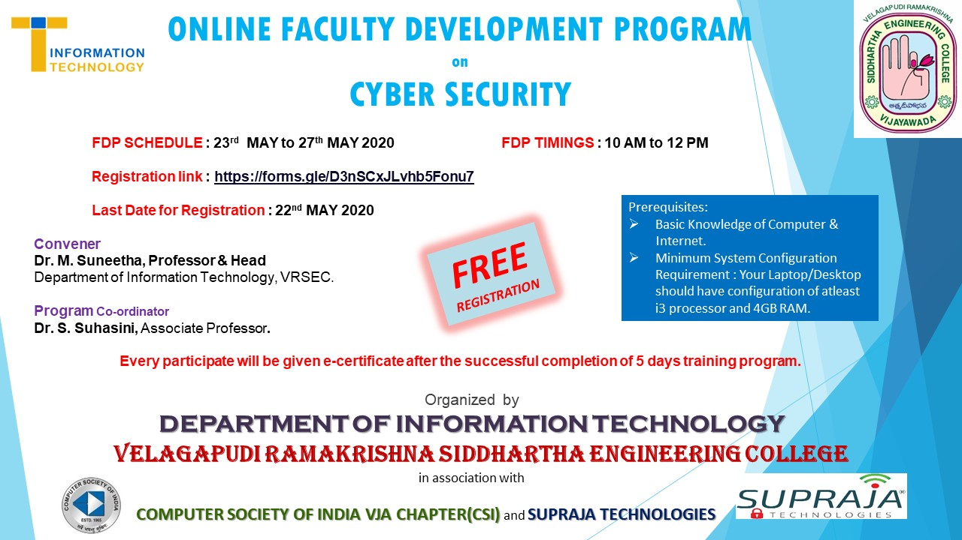

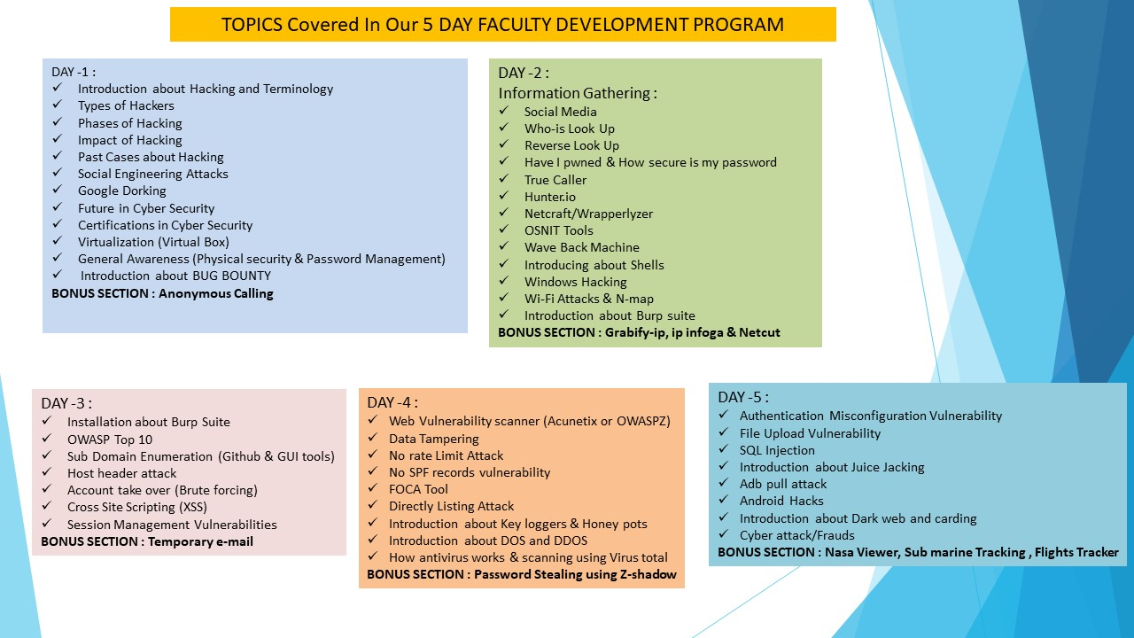

Circular : Through WhatsApp

Subject: Five Day Online Faculty Development Program On “CYBER SECURITY”

Dear All,  
  
Warm Greetings from V R Siddhartha Engineering College!!!

Welcome to the Five Day FDP on Cyber Security!

Department of Information Technology, Velagapudi Ramakrishna Siddhartha Engineering College, Vijayawada, A.P is organizing a Five Day Faculty Development Program on “CYBER SECURITY” in association with Computer Society of India (CSI) Vijayawada Chapter, and Supraja Technologies, from **23rd - 27th, May 2020 at 10AM to 12PM**.

The objective of this program is to enable researchers to learn via theory and hands-on sessions on hacking, attacks, Information gathering, current tools and technologies in cyber security.

We thank you for showing your interest to participate in this enormous 5 days online training session, which helps to learn and nurture your skills.

All the participants are informed to join for class sessions from May 23, 2020 to May 27, 2020. Time :  10:00 AM To 12:00 PM IST

Click the link below:

*NOTE :*  First initially every participant, kindly create an account in  <https://zoom.us/>  
  
Then with your Zoom registered email address, Join the FDP by clicking the following link below :  
<https://zoom.us/j/98931382147?pwd=TFZoWjJiN3J3NnZpUXZubFBXWDRKZz09>  
  
Meeting ID :  989 3138 2147  
Password :  262050

E-Certificate will be provided to participants only after filling the feedback form by 27-05-2020 4PM.

With Regards,

Convener and Event Coordinator

4. Session – wise report: Day 01 (23-05-2020)

|  |  |
| --- | --- |
| **TIME** | **EVENT** |
| **10.00AM – 10.10AM** | **Convener Address** |
| **10.10AM-12.30PM** | **SESSION I** |
| * Introduction about Hacking and Terminology * Types of Hackers * Phases of Hacking * Impact of Hacking * Past Cases about Hacking * Social Engineering Attacks * Google Dorking * Future in Cyber Security * Certifications in Cyber Security * Virtualization (Virtual Box) * General Awareness (Physical security & Password Management) * Introduction about BUG BOUNTY   **BONUS SECTION : Anonymous Calling** |

On the first day, Mr.Santhosh Chaluvadi started his discussion on hacking and its basic concepts. Further types of hackers, threats, attacks and phases of hacking were explained in detail. The impact of hacking is also demonstrated. Social engineering attacks, google dorking to perform advanced search is also visualized. The concept of virtual server and process of virtualization is delivered. Password management techniques are elaborated. He explained various certification courses in cyber security were highlighted. of teaching i.e. general objectives and specific objectives of syllabus and importance of media.

**DAY 2 (24-05-2020)**

|  |  |
| --- | --- |
| **TIME** | **EVENT** |
| **10.00AM-12PM** | **SESSION II** |
| **INFORMATION GATHERING :**   * Social Media * Who-is Look Up * Reverse Look Up * Have I pwned& How secure is my password * True Caller * Hunter.io * Netcraft/Wrapperlyzer * OSNIT Tools * Wave Back Machine * Introducing about Shells * Windows Hacking * Wi-Fi Attacks & N-map * Introduction about Burp suite   **BONUS SECTION : Grabify-ip, ipinfoga& Netcut** |

In the second session information gathering is explained through social media, lookup procedures. Password security is explained with pwn. The app true caller for identification of users is demonstrated practically. Various tools like hunter.io, netcraft, osnit, wave back machine, windows hacking , wifi attacks are shown practically.

**DAY 3 (25-05-2020)**

|  |  |
| --- | --- |
| **TIME** | **EVENT** |
| **10.00AM-12PM** | **SESSION III** |
| * Installation about Burp Suite * OWASP Top 10 * Sub Domain Enumeration (Github& GUI tools) * Host header attack * Account take over (Brute forcing) * Cross Site Scripting (XSS) * Session Management Vulnerabilities   **BONUS SECTION : Temporary e-mail** |

On the third day of the session installation of burpsuite is shown. All participants has installed successfully. Bruteforce attacks, host header attacks, XSS are demonstrated. The vulnerabilities are also explained in this regard.

**DAY 4 (26-05-2020)**

|  |  |
| --- | --- |
| **TIME** | **EVENT** |
| **10.00AM-12PM** | **SESSION IV** |
| * Data Tampering * No rate Limit Attack * No SPF records vulnerability * FOCA Tool * Directly Listing Attack * Introduction about Key loggers & Honey pots * Introduction about DOS and DDOS * How antivirus works & scanning using Virus total   **BONUS SECTION : Password Stealing using Z-shadow** |

On the fourth day of the session data tampering attacks are shown. For this FOCA tool is used. Other tools like honeypots, keyloggers are visulaized practically. DoS and DDoS attacks were shown. The importance of anti virus and its impact is shown using virus total.

**DAY 5 (27-05-2020)**

|  |  |
| --- | --- |
| **TIME** | **EVENT** |
| **10.00AM-11.30PM** | **SESSION V** |
| * Authentication Misconfiguration Vulnerability * File Upload Vulnerability * SQL Injection * Introduction about Juice Jacking * Adbpull attack * Android Hacks * Introduction about Dark web and carding * Cyber attack/Frauds   **BONUS SECTION : Nasa Viewer, Sub marine Tracking , Flights Tracker** |
| **11.30AM-12PM** | Online Exam and Feedback |

The last day of the session is concluded with SQL injection attacks, android attacks, cyber attacks etc. Dark web is shown practically with real implementations.

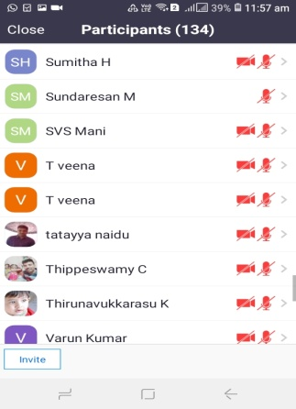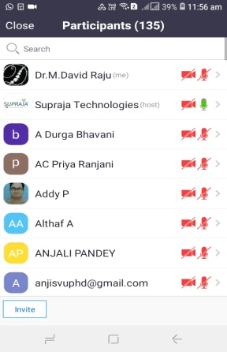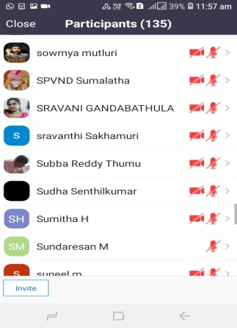5. Attendance sheet:

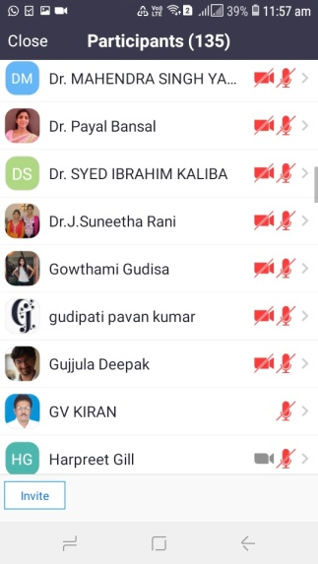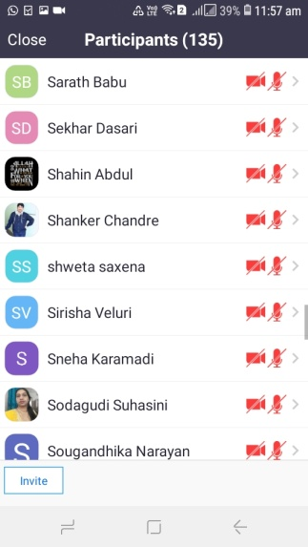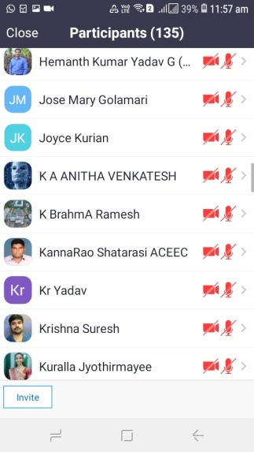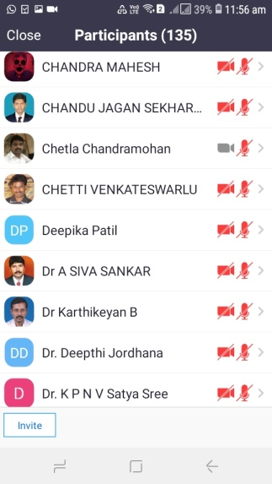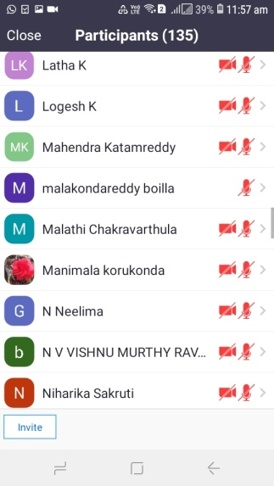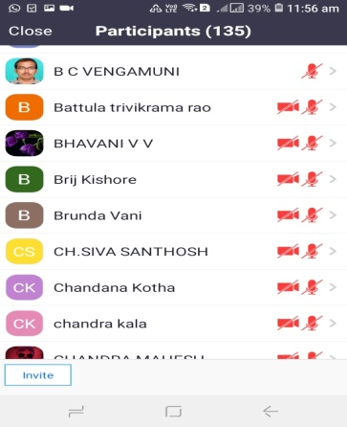

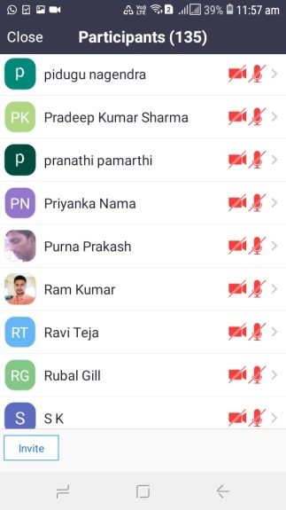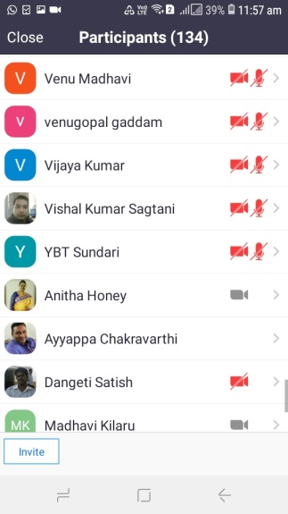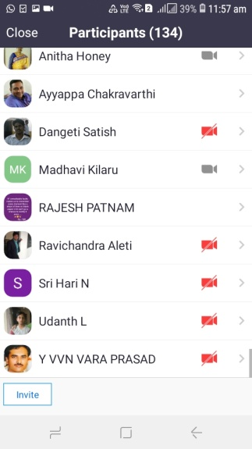

Fig : Online Attendance Sheet

Feedback Form:<https://forms.gle/nYNoZ7eUvVcXhJe17>

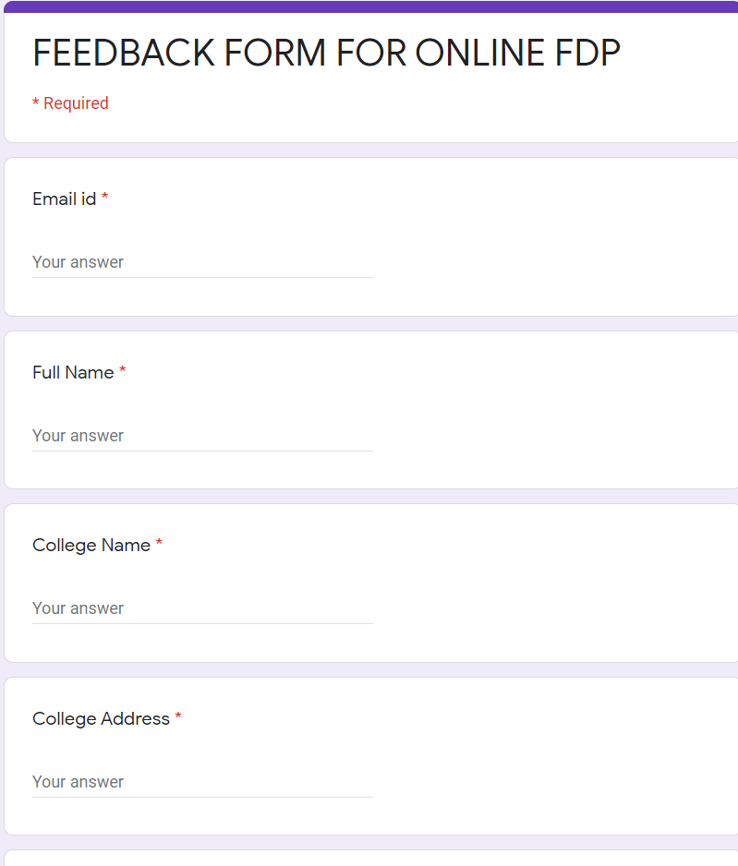

1. **Can you please mention your motivation to attend this FDP?**

* **Suggested by someone**
* **Attain knowledge and Improve skill**
* **Research**
* **Intellectual Assets protecting**
* **All of the Above**

1. **Kindly give rating to the different aspects of FDP (Out of 10 marks)**

**Particulars Marks Given Any Remarks**

**(a). Course Content ____________ _______________________________**

**(b). Course Delivery ____________ _______________________________**

**(c). Overall ____________ _______________________________**

1. **How do you rate the audio/video clarity of the sessions**

**1 2 3 4 5**

1. **Audio**
2. **Video**
3. **Content**
4. **Have you gained any knowledge from these five days FDP sessions**

**Yes**

**No**

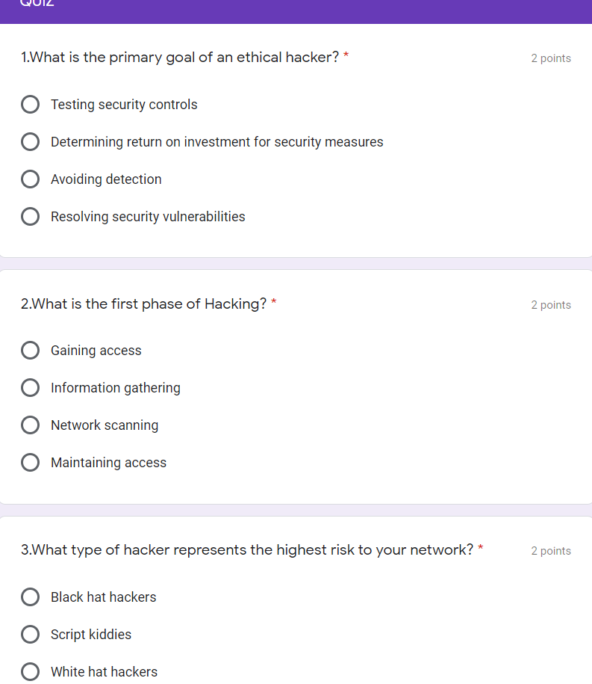Online Exam conducted on 27th May 2020 - Quiz Form: <https://forms.gle/bpFSdKcifBmk2HaT8>

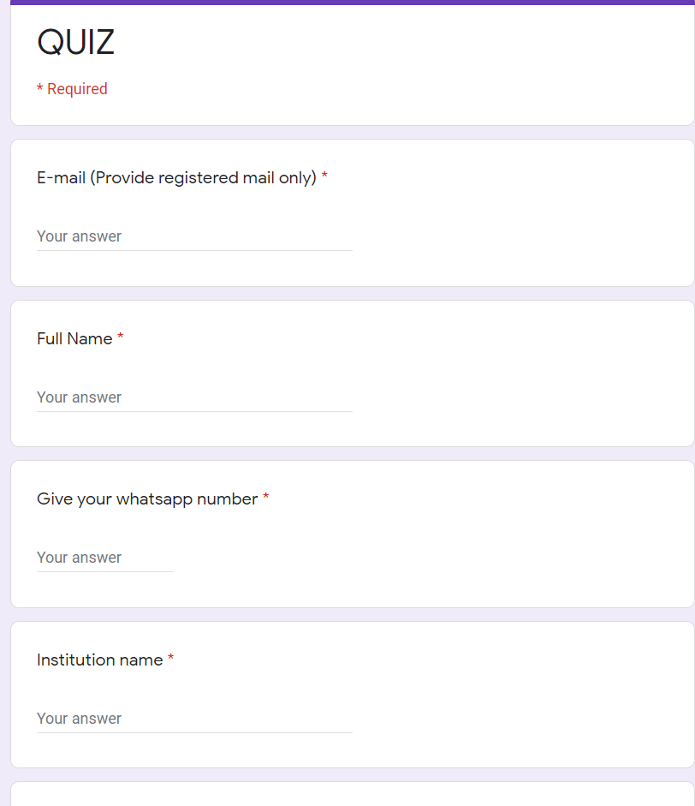

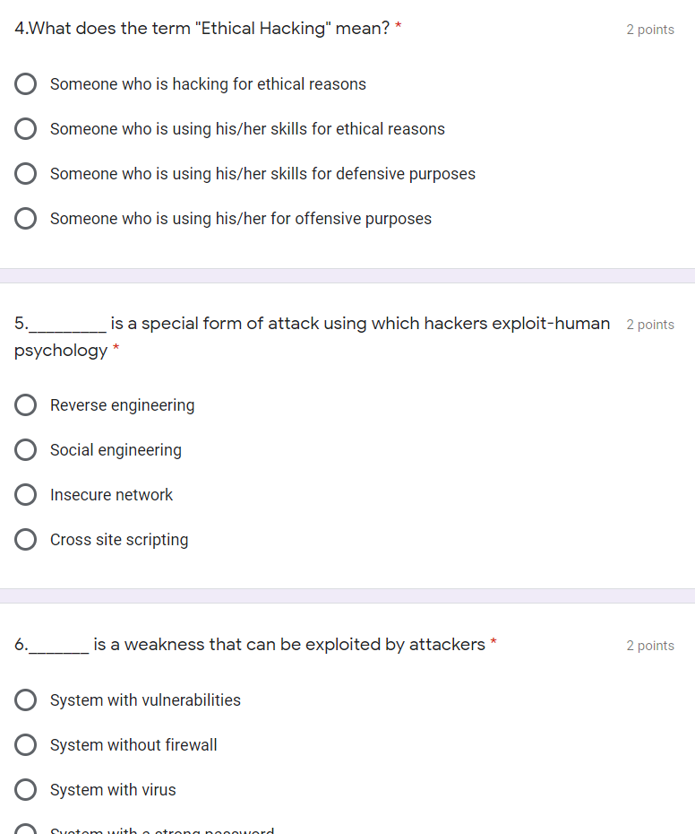

E-Certificate Template :

