A Report on Guest Lecture by “Ar. Ch. Anil Kumar, Associate Professor, School of Planning and architecture, Vijayawada on “In Search of Humanistic Built Environment” organised by ICI_VRSEC Student Chapter, Civil Engineering Department on 29th January 2021 @ V R Siddhartha Engineering College, Vijayawada
The Indian Concrete Institute-V R Siddhartha Engineering College Student Chapter (ICI-VRSEC Student Chapter, Civil Engineering Department, V R Siddhartha Engineering College has organized guest lecture by Ar. Ch. Anil Kumar on “In Search of Humanistic Built Environment” on 29th January 2021 at Seminar Hall, VRSEC. In this one-day workshop around 100⁺ students of U.G., P.G., Ph.D. scholars and Faculty were participated from V R Siddhartha Engineering College.
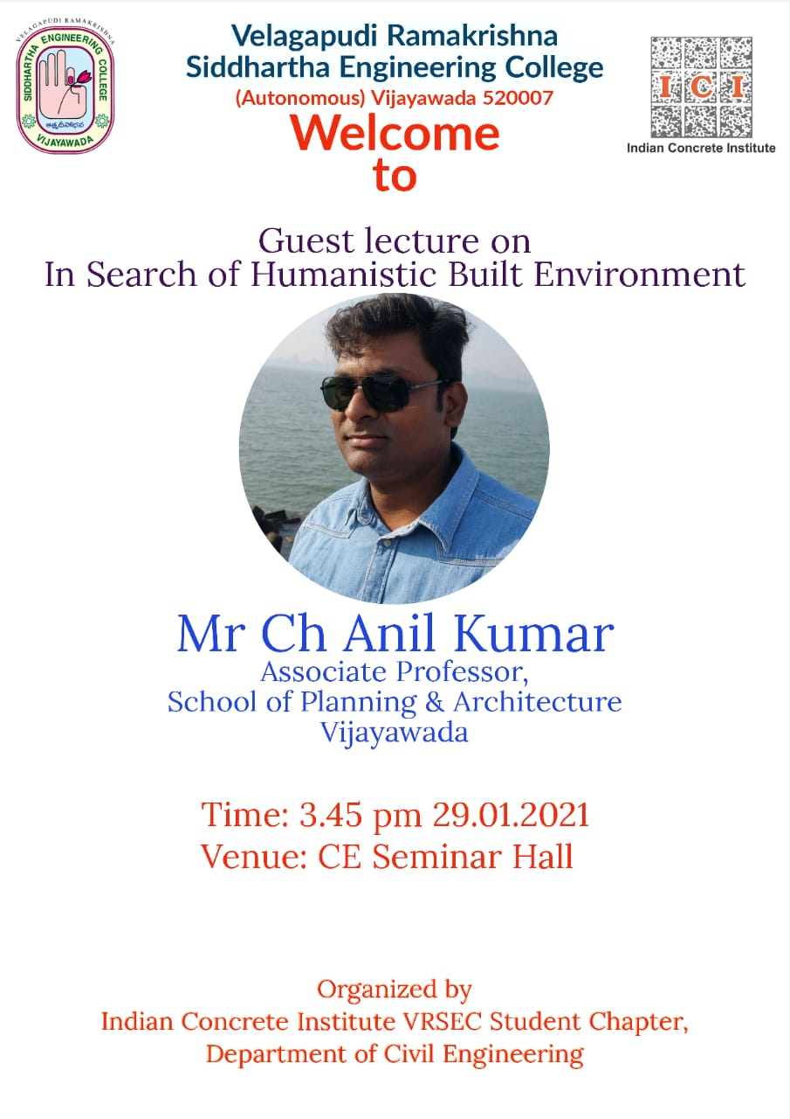
- Dr. Ch. Srinivas, HoD-CE, VRSEC addressed the gathering and welcomed the guest speaker. Also, welcomed the students and faculty participant from Civil Engineering Department. He talked about the importance of the guest lecture. How best it is going to useful to the participants. Also, appreciated the all student organising committee and department faculty coordinators.
- Dr. P. Poluraju, ICI- Faculty Coordinator, Civil Engineering Department, VRSEC & Chairperson, ICI Vijayawada Centre & Coordinator of Guest Lecture, welcomed the gathering and introduced the Expert Speaker “Ar. Ch. Anil Kumar” to the all participants.
- Ar. Ch. Anil Kumar, Associate Professor, School of Planning and architecture, Vijayawada, Guest Speaker have delivered expert talk on “In Search of Humanistic Built Environment” on 29th January 2021 at Seminar Hall, VRSEC. Ar. Ch. Anil Kumar has emphasized in his delivery on very good topics such as Who are we?, Where are we?, We are under process of time only?, Time-Space-Order & Dynamics?. Also, talked about famous Architects throughout the world and their contributions to the society, perception, eco cultural traditions, and energy. At final, he talked about few completed and ongoing architectural projects and their significance and his involvement in those projects etc.
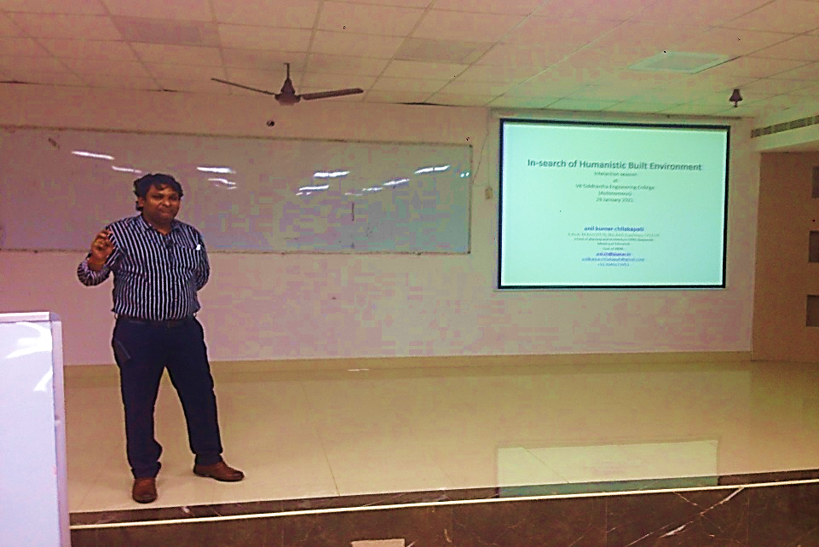
“Few Glimpses of Guest Lecture on 29th January 2021”
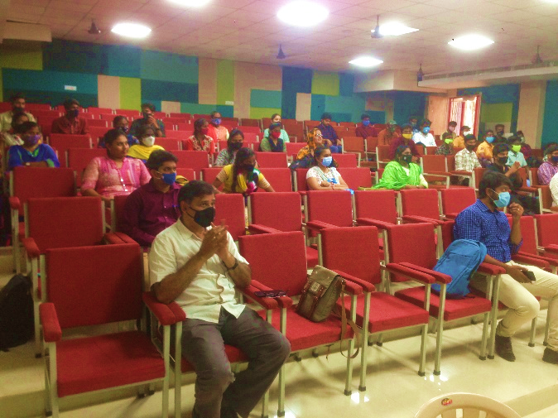 | 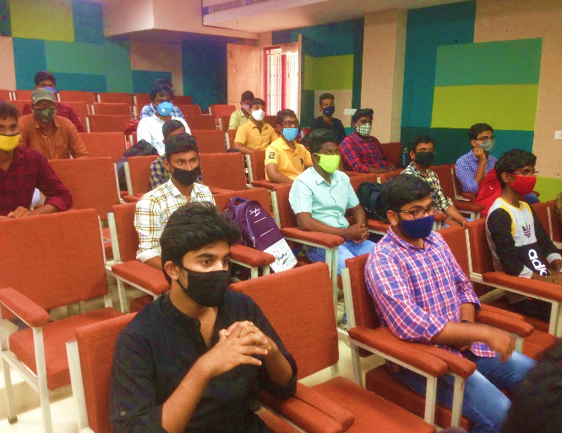
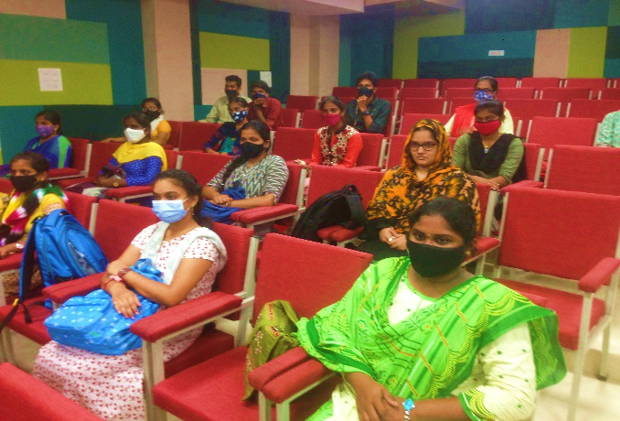 | 